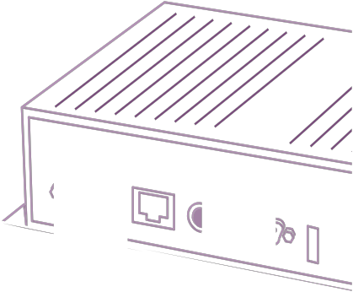
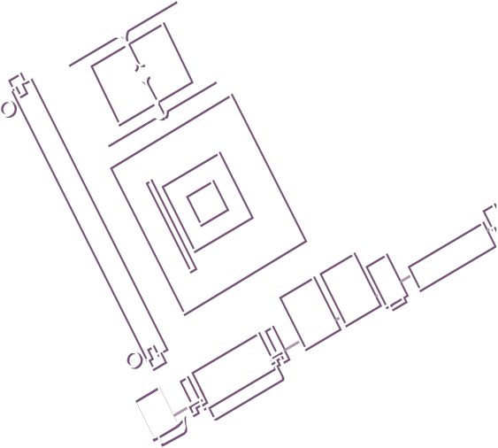

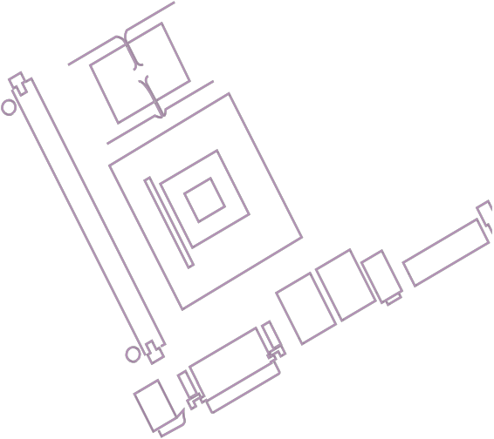
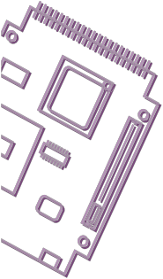
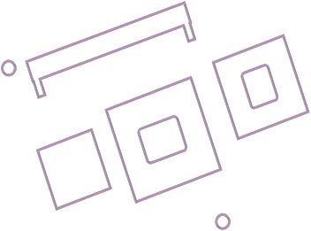
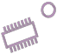
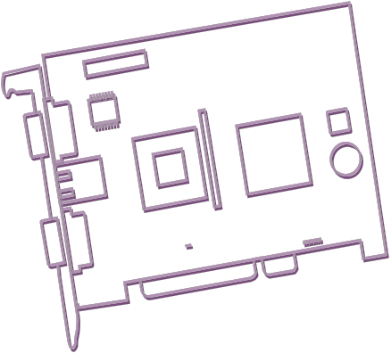
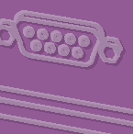


Carrier Board
Design Guide

ROM-2620 Rev:004

Arm-based OSM Module with NXP i.MX8ULP arm® Cortex™A35/M33 Processor

Chapter
1. Introduction - 6 -
1.1 About This Document - 6 -
1.2 Signal Table Terminology - 6 -
1.3 Terminology - 6 -
1.4 Reference Documents - 9 -
1.5 Revision History - 9 -
2. OSM Size Definition - 10 -
2.1 Outline Dimensions - 10 -
2.2 OSM Size-S Pin-out - 12 -
2.2.1 OSM Size-S Pin-out - 13 -
2.3 ROM-2620 System Block Diagram - 19 -
2.4 RMII Interface - 20 -
2.4.1 RMII signal layout guide - 21 -
2.4.2 LAN Signal Definitions - 22 -
2.4.3 LAN Implementation Guidelines - 23 -
2.4.4 LAN Magnetics Modules - 23 -
2.4.5 LAN Component Placement - 24 -
2.4.6 LAN Ground Plane Separation - 24 -
2.4.7 LAN Link Activity and Speed LED - 25 -
2.4.8 LAN Trace Length Guidelines - 25 -
2.4.9 Reference Ground Isolation and Coupling - 26 -
2.5 USB - 27 -
2.5.1 USB A Client / Host direct from Module (USB 2.0) - 28 -
2.5.2 USB B Host Mode - 30 -
2.5.3 USB2.0 Routing Guidelines - 31 -
2.5.4 USB 2.0 Port Power Delivery - 31 -
2.5.5 USB Client Considerations - 32 -
2.5.6 USB2.0 Trace Length Guidelines - 33 -
2.5.7 USB Connector EMI / ESD Protection - 34 -
2.6 SDIO Interface - 36 -
2.6.1 SDIO for SD card boot device or storage - 37 -
2.6.2 SDIO for the Wireless Modules. - 38 -
2.6.3 SDIO Interface Routing Guidelines - 39 -
2.7 I2S Interface - 40 -
2.7.1 Audio Routing Guidelines - 42 -
2.7.2 Audio Trace Length Guidelines - 43 -
2.8 MIPI-DSI - 44 -
2.8.1 MIPI-DSI to LVDS - 46 -
2.8.2 LVDS Trace Length Guidelines - 47 -
2.9 MIPI-CSI Interface Signals - 48 -
2.10 General purpose input/output - 50 -
2.11 CAN Interface - 52 -
2.11.1 CAN interface Signal Definitions - 53 -
2.11.2 Interface Routing Guidelines - 53 -
2.11.3 Interface Trace Length Guidelines - 53 -
2.12 Serial Peripheral Interface Bus - 54 -
2.12.1 SPI Signal Definition - 54 -
2.12.2 SPI Trace Length Guidelines - 55 -
2.13 QSPI - 56 -
2.14 General Purpose I2C Bus Interface - 57 -
2.14.1 Signal Definitions - 57 -
2.14.2 Connectivity Considerations - 58 -
2.15 UART - 59 -
2.15.1 UART interface Signal and Debug Port Definitions - 59 -
2.15.2 Serial interface Trace Length Guidelines - 60 -
2.16 Miscellaneous Signals - 61 -
2.16.1 Power and GND - 61 -
2.16.2 JTAG - 62 -
2.16.3 PWM - 62 -
2.16.4 Boot configuration - 63 -
2.16.5 Module Terminations - 65 -
ROM-2620 Module uses these pins be boot configuration, and Carrier Board should use < 1K resistor pull-down. Please check the section: 2.16.4 Boot configuration. - 65 -
ROM-2620 Module uses these pins be boot configuration, and Carrier Board should use < 1K resistor pull-down. Please check the section: 2.16.4 Boot configuration. - 65 -
2.16.6 Reserved - 66 -
Please check the section: 2.16.4 Boot configuration - 66 -
2.16.7 Vendor Defined Contact - 66 -
2.16.8 Voltage Test Contacts - 67 -
3. Electrical Characteristics - 68 -
3.1 Absolute Maximum Ratings - 68 -
3.2 DC Characteristics - 68 -
3.3 Power Management Signals - 68 -
3.3.1 CARRIER_PWR_EN - 70 -
3.3.2 SYS_RST# - 71 -
3.3.2 PWR_BTN# - 72 -
3.3.3 Power on sequence - 73 -
3.3.4 ROM-2620 Module Input - 74 -
3.3.5 DC Input and OVP/OCP Protect - 75 -
3.3.6 AT and ATX - 75 -
3.4 FORCE_RECOVERY# - 77 -
3.5 RTC Battery - 77 -
3.5.1 RTC Battery Lifetime - 77 -
4. Mechanism dimension - 79 -
4.1 Contact Grid - 79 -
4.2 Footprint Grid - 80 -
4.3 Possible Cut-out and Placement Areas (bottom side) - 81 -
4.4 Breakout Area and Tolerances - 82 -
4.5 Outline Dimensions - 83 -

Figure 1 : Overview (view from top, through the module) - 10 -
Figure 2 : Sizes (view from top, through the module) - 10 -
Figure 3 : Size-S detailed Contact Overview - 11 -
Figure 4 : OSM Size-S Pin-out - 12 -
Figure 5 : Module Block Diagram - 19 -
Figure 6 : RMII MAC/PHY interface - 20 -
Figure 7 : ROM-ED91 Lan PHY schematic - 22 -
Figure 8 : Lan PHY MDI Signals - 24 -
Figure 9 : LAN LED Circuit. - 25 -
Figure 10 : Micro-USB circuit of ROM-ED91 - 29 -
Figure 11 : USB 2.0 type A connector circuit - 30 -
Figure 12 : USB 2.0 HUB circuit of ROM-ED91 - 30 -
Figure 13 : USB 2.0 Good Downstream Power Connection - 32 -
Figure 14 : Topology for USB2.0 - 33 -
Figure 15 : USB 2.0 Common Mode Chokes and ESD - 34 -
Figure 16 : The SDIO circuit of the ROM-ED91 - 38 -
Figure 17 : Topology for SDIO - 39 -
Figure 18 : I2S circuit of ROM-ED91 - 41 -
Figure 19 : Audio Codec circuit SGTK5000 - 41 -
Figure 20 : Topology for Audio - 43 -
Figure 21 : DSI diagram. - 45 -
Figure 22 : ROM-ED91 DSI to LVDS circuit - 46 -
Figure 23 : ROM-ED91 VDD and backlight circuit - 47 -
Figure 24 : ROM-ED91 Camera CSI connector design. - 49 -
Figure 25 : ROM-ED91 Can bus circuit - 52 -
Figure 26 : Topology for CAN Interface - 53 -
Figure 27 : Topology for SPI - 55 -
Figure 28 : ROM-ED91 QSPI circuit - 56 -
Figure 29 : ROM-ED91 Boot Configuration circuit - 64 -
Figure 30 : ROM-ED91 Carrier_PWR_EN circuit - 70 -
Figure 31 : The ROM-2620 Carrier_PWR_EN RC rise waveform - 71 -
Figure 32 : Reset button Key design - 71 -
Figure 33 : ROM-ED91 Power button Key circuit - 72 -
Figure 34 : Power button Key circuit with ESD - 72 -
Figure 35 : ROM-ED91 AT Power-On Sequence - 73 -
Figure 36 : ROM-ED91 ATX Power-On Sequence (check the 3.3.6 AT and ATX section) - 73 -
Figure 37 : ROM-ED91 Power-off Sequence (Note 19: Case by designer request) - 74 -
Figure 38 : ROM-ED91 Power Distribution - 75 -
Figure 39 : ROM-ED91 Module Power Circuit - 76 -
Figure 40 : Module Power for AT and ATX - 77 -
Figure 41 : RTC Circuit. - 78 -
Figure 42 : Contact Grid (view from top, through the module) - 79 -
Figure 43 : ROM-2620 View from TOP & ROM-2620 Flip View - 79 -
Figure 44 : Footprint Grid Dimensions - 80 -
Figure 45: Placement Area (left) and Cut-Out Area (right) - Size S (view from bottom) - 81 -
Figure 46 : Breakout Areas (view from top, through the module) - 82 -
Figure 47 : Size-S Dimension and Footprint (view from top, through the module) - 83 -
Figure 48 : Module Height - 83 -

Table 1 Conventions and Terminology - 6 -
Table 2 ROM-2620 on OSM S size - 13 -
Table 3 ROM-2620 Supported Features - 18 -
Table 4 Rom-2620 RMII Interface Pins out - 20 -
Table 5 MDI interface - 23 -
Table 6 MDI Trace Length Guidelines - 25 -
Table 7 Rom-2620 USB2.0 Interface Pins out - 27 -
Table 8 USB2.0 Trace Length Guidelines - 33 -
Table 9 Rom-2620 SDIO Interface Pins out - 36 -
Table 10 SDIO Trace Length Guidelines - 39 -
Table 11 Rom-2620 I2S Interface Pins out - 40 -
Table 12 Audio Trace Length Guidelines - 43 -
Table 13 Rom-2620 MIPI-DSI Interface Pins out - 44 -
Table 14 DSI Trace Length Guidelines - 45 -
Table 15 LVDS Trace Length Guidelines - 47 -
Table 16 Rom-2620 MIPI-CSI Interface Pins out - 48 -
Table 17 Rom-2620 GPIO Interface Pins out - 50 -
Table 18 Rom-2620 CAN Bus Interface Pins out - 53 -
Table 19 CAN Trace Length Guidelines - 53 -
Table 20 Rom-2620 SPI Interface Pins out - 54 -
Table 21 SPI Trace Length Guidelines - 55 -
Table 22 Rom-2620 QSPI Interface Pins out - 56 -
Table 23 Rom-2620 I2C Interface Pins out - 57 -
Table 24 ROM-ED91 I2C address - 57 -
Table 25 I2C Trace Length Guidelines - 57 -
Table 26 Rom-2620 UART Interface Pins out - 59 -
Table 27 Serial Interface Trace Length Guidelines - 60 -
Table 28 Rom-2620 Power and GND Interface Pins out - 61 -
Table 29 Rom-2620 JTAG Interface Pins out - 62 -
Table 30 Rom-2620 PWM Interface Pins out - 62 -
Table 31 Rom-2620 Boot Configure Interface Pins out - 63 -
Table 32 Boot Configure table - 64 -
Table 33 BOOT MODE of the Boot selection pins - 65 -
Table 34 ROM-ED91 boot configure table - 65 -
Table 35 Module Terminations - 65 -
Table 36 Rom-2620 RESERVED Interface Pins out - 66 -
Table 37 Rom-2620 Vendor Defined Interface Pins out - 67 -
Table 38 Rom-2620 VCC_x_TEST Interface Pins out - 67 -
Table 39 Absolute Maximum Ratings - 68 -
Table 40 Power Management Signal Definitions - 68 -
Table 41 Power Management Signal Definitions - 69 -
Table 42 Power Management Timings - 73 -
Table 43 Limiting Input Power - 74 -

Introduction

About This Document
This document provides information for designing a custom system carrier board for OSM(Open Standard Module) modules.
It includes Signal Descriptions, Routing Guidelines, and Trace Length Guidelines. The main purpose is designing the Carrier Board for helping customers fast and easy using the module of Advantech to be designed.

Signal Table Terminology
Table 1 below describes the terminology used in this section for the Signal Description tables.
The “#” symbol at the end of the signal name indicates that the active or asserted state occurs when the signal is at a low voltage level. When “#” is not present, the signal is asserted when at a high voltage level.
The terms “Input” and “Output” and their abbreviations in Table 1 below refer to the Module's view, i.e. input is an input for the Module and not for the Carrier-Board.

Terminology
Table 1 Conventions and Terminology
Terminology | Description
ADC | Analog to Digital Converter
ARM | Advanced RISC Machines---------------------------------------------- www.arm.com
BCT | Boot Configuration Table
BSP | (software) Board Support Package
CAD | Computer Aided Design
CAN | Controller Area Network
CSI | (MIPI) Camera Serial Interface---------------------------------------www.mimpi.org
DP | DisplayPort
DP++ | Dual-mode DisplayPort
DSP | Digital Signal Processor
DSI | (MIPI) Camera Serial Interface----------------------------------------------www.mimpi.org
EDID | Extended Display Identification Data----------------------------------------- www.vesa.org
EEPROM | Electrically Erasable Programmable Read Only Memory
e-MMC | Embedded Multi Media Card ----------------------------------------------- www.jedec.org
ESD | Electro Static Discharge
GBE | Gigabit Ethernet---------------------------------------------------------------www.ieee.org
Gbps | Gigabit per second
GPIO | General Purpose Input Output
GPO | General Purpose Output
HAD | High Definition Audio
HDMI | High Definition Multimedia Interface. HDMI supports standard, enhanced, or  high-definition video, plus multi-channel digital audio on a single cable.
I | Input Pin
I2S | Integrated Interchip Sound (I2S) is an electrical serial bus interface standard  used for connecting digital audio devices.
Legacy Device | Relics from the PC-AT computer that is not in use in contemporary PC  systems: primarily the ISA bus, UART-based serial ports, parallel printer ports, PS-2 keyboards, and mice.  Definitions vary as to what constitutes a legacy device. Some definitions include IDE as a legacy device.
LPC | Low Pin-Count Interface: a low-speed interface used for peripheral circuits  such as Super I/O controllers, which typically combine legacy-device support into a single IC.
LS | Least Significant
LVDS | Low-Voltage Differential Signaling
N.A. | Not available
N.C. | Not connected
O | Output Pin
OD | Open-Drain
P | Power Pin
PCB | Printed Circuit Board
PCI Express (PCIe) | Peripheral Component Interface Express. Next-generation high speed  serialized I/O bus
PCI Express Lane | One PCI Express Lane is a set of 4 signals that contains two differential lines for Transmitter and two differential lines for Receiver. Clocking information is embedded in the data stream.
PD | Pull Down
PEG | PCI Express Graphics
PHY | Ethernet controller physical layer device
PP | Push-Pull
PS2  PS2 Keyboard PS2 Mouse | “Personal System 2” - an IBM trademark term used to refer to Intel x86  based on personal computers in the 1990s. The term survives as a reference to the style of mouse and keyboard interface that was introduced with the PS2 system.
QSPI | A Queued Serial Peripheral Interface (QSPI) is a type of SPI controller that uses a data queue to transfer data across the SPI bus.
RoHS | Restriction on Hazardous Substances: The Directive on the Restriction of  the Use of Certain Hazardous Substances in Electrical and Electronic Equipment 2002/95/EC.
RTC | Real-Time Clock – battery-backed circuit in PC-AT systems that keep  system time and date as well as certain system setup parameters
S0, S1, S2, S3, S4, S5 | Sleep States defined by the ACPI specificationS0 Full power, all devices  powered  S1Sleep State, all context maintained  S2 Sleep State, CPU and Cache context lost  S3 Suspend to RAM System context stored in RAM; RAM is in standby S4 Suspend to Disk System context stored on disk  S5 Soft Off Main power rail off, only standby power rail present
SATA | Serial AT Attachment: serial interface standard for hard disks.
SDIO | Secure Digital Input Output
SMB | System Management Bus
SPI | Serial Peripheral Interface
T.B.D. | To be determined
TMDS | Transition Minimized Differential Signaling. TMDS is a signaling interface  defined by Silicon  The image that is used for DVI and HDMI.
TPM | Trusted Platform Module, chip to enhance the security features of a  computer system.
USB | Universal Serial Bus
VESA | Video Electronics Standards Association
WDT | Watchdog Timer
x1, x2, x4 | x1 refers to one PCI Express Lane of basic bandwidth; x2 to a  collection of two PCI Express Lanes; etc.. Also referred to as x1, x2, x4 link.
X86 | The term x86 refers to a family of instruction set architectures based on the  Intel 8086.
TMDS | Transition Minimized Differential Signaling. TMDS is a signaling interface  defined by Silicon  The image that is used for DVI and HDMI.

Reference Documents

Document
OSM Design Guide 1.0 (May 3, 2022)
Open Standard Module V1.1 (May 4, 2022)

Hardware Specification

Revision History
Revision | Date | PCB Rev. | Changes
001 | Dec 05, 2023 | A101-2 | Initial Release ROM-2620 design for OSM1.1
002 | Mar 20, 2024 | A101-2 | Add Mechanism dimension chapter  Add Contact Overview figure
003 | Apr 15, 2024 | A101-2 | - Add the SDIO_A_PWR_EN pull high 1K ohm to 1.8V for boot from SD card  - Modify the table 17: GPIO_C_2 (CPU Pin-out) to H6 / GPIO_C_3 (CPU Pin-out) to C2
004 | Jun 3, 2024 | A101-2 | - Section 2.15.1 "UART Interface Signal and Debug Port Definitions" to clearly specify the debug locations.  - “table4” “table35” “table36” “table41”  - Section 3.3.6 AT and ATX

OSM Size Definition

Outline Dimensions
The Open Standard Module™ is made up of four different sizes that build upon each other:
▪ Size-0 – “Zero”: 30 mm x 15 mm / with 188 contacts → shown below with red outlines
▪ Size-S – “Small”: 30 mm x 30 mm / with 332 contacts → shown below with blue outlines
▪ Size-M – “Medium”: 30 mm x 45 mm / with 476 contacts →shown below with orange outlines
▪ Size-L – “Large”: 45 mm x 45 mm / with 662 contacts → shown below with green outlines

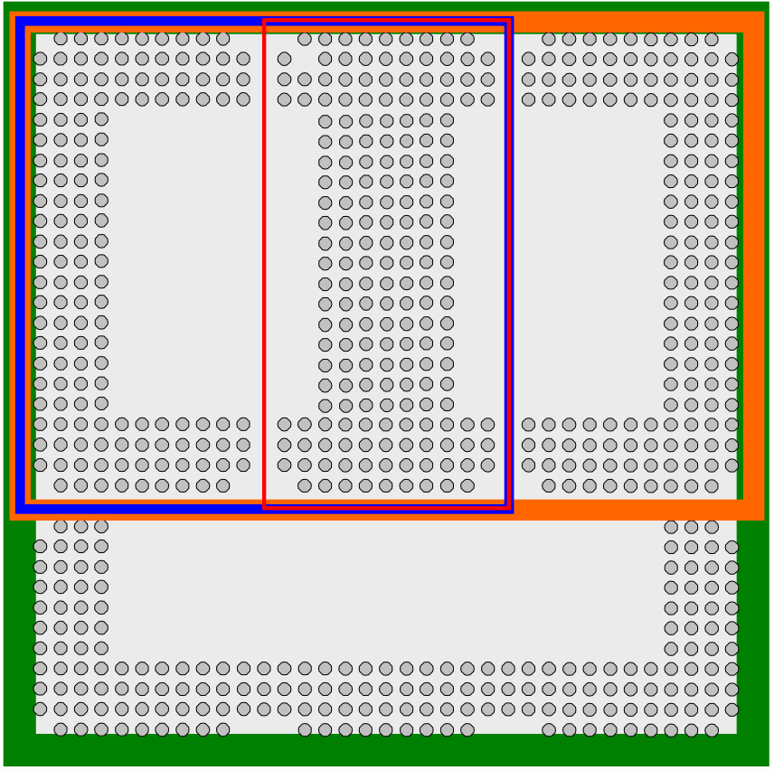
Figure 1 : Overview (view from top, through the module)
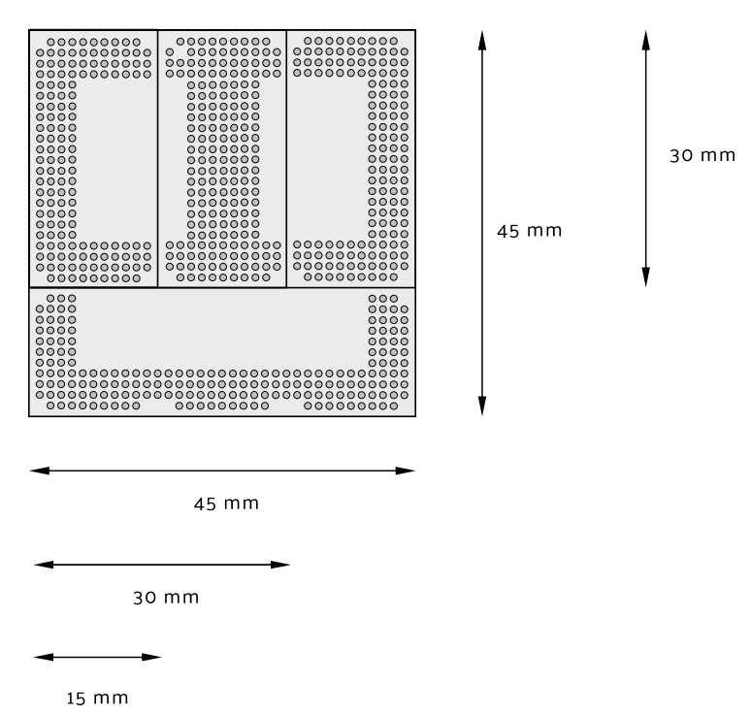

Figure 2 : Sizes (view from top, through the module)

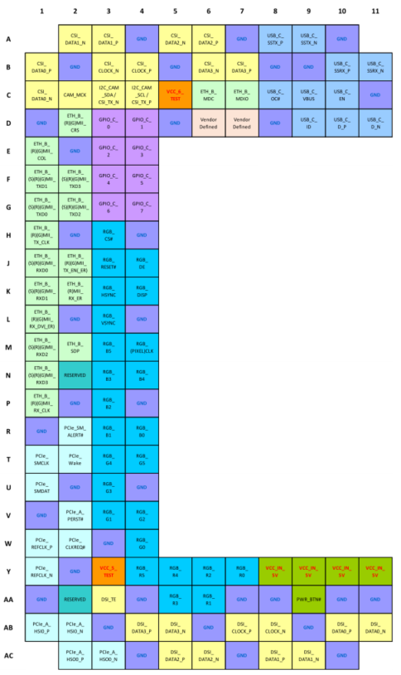
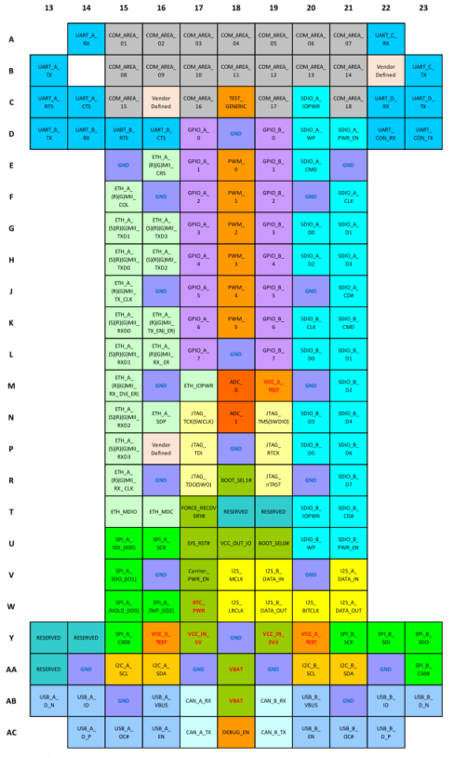

Figure 3 : Size-S detailed Contact Overview

OSM Size-S Pin-out

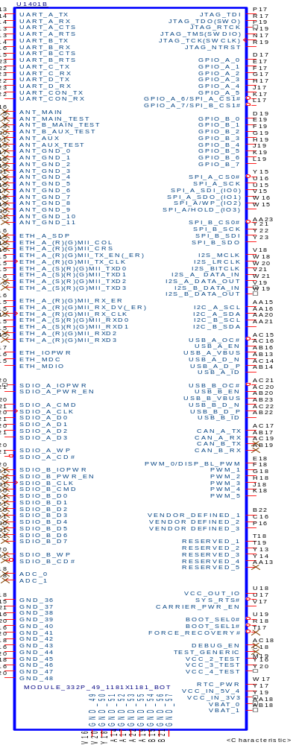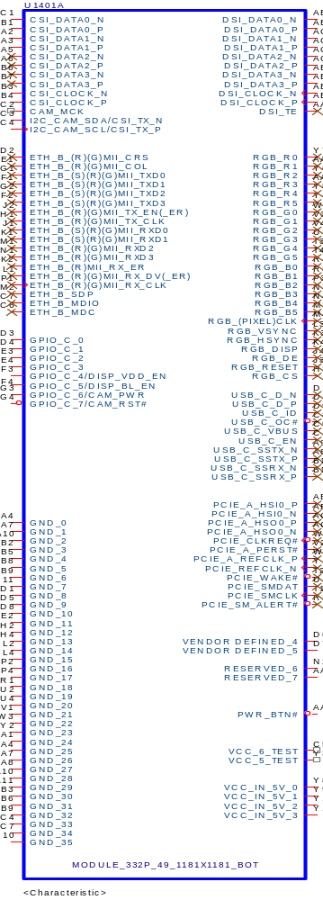

Figure 4 : OSM Size-S Pin-out

2.2.1 OSM Size-S Pin-out

The table is the ROM-2620(OSM-S) pins definition, and the others un-define the ROM-2620 would not use please keep them unconnected and floating.

Table 2 ROM-2620 on OSM S size

Power-GND and Control | Contact Name | Contact Acronym | ROM-2620
Size-S | VCC_2_TEST² | M19 | +VBUCK1_LSW1_CPU_1V8
Size-S | VCC_3_TEST | Y16 | +VBUCK1_1V8
Size-S | VCC_IN_5V | Y17 | +VCC_IN_5V
Size-S | GND | D18, E15, E21, F16, F20, J16, J20, L18, M16, M20, P18, R16, R20, V16, V20, Y18, AA14, AA17, AA19, AA22, AB15, AB21,A4, A7, A10, B2, B5, B8, B9, C11, D1, D5, D8, E2,H2, H4, L2, L4, P2, P4, R1, U2, U4, V1, W3, Y2, AA1, AA4, AA7, AA8, AA10, AA11, AB3, AB6, AB9, AC4, AC7, AC10 | GND
Size-S | SYS_RST# | U17 | SYS_RST#
Size-S | CARRIER_PWR_EN | V17 | CARRIER_PWR_EN
Size-S | VCC_OUT_IO | U18 | +VBUCK1_1V8
Size-S | RTC_PWR | W17 | +RTC
Size-S | BOOT_SEL0# | U19 | BOOT_SEL0#
Size-S | BOOT_SEL1# | R18 | BOOT_SEL1#
Size-S | VCC_IN_5V | Y8, Y9, Y10, Y11 | +VCC_IN_5V
Size-S | PWR_BTN# | AA9 | ONOFF

JTAG | Contact Name | Contact Acronym | ROM-2620
Size-S | JTAG_TCK(SWCLK) | N17 | JTAG0_TCLK
Size-S | JTAG_TMS(SWDIO) | N19 | JTAG0_TMS
Size-S | JTAG_TDI | P17 | JTAG0_TDI
Size-S | JTAG_TDO(SWO) | R17 | JTAG0_TDO
Size-S | JTAG_nTRST | R19 | JTAG0_TRST#

UART | Contact Name | Contact Acronym | ROM-2620
Size-S | UART_A_RX | A14 | LPUART4_RX
Size-S | UART_A_TX | B13 | LPUART4_TX
Size-S | UART_A_RTS | C13 | LPUART4_RTS#
Size-S | UART_A_CTS | C14 | LPUART4_CTS#
Size-S | UART_B_RX | D14 | LPUART2_RX
Size-S | UART_B_TX | D13 | LPUART2_TX
Size-S | UART_B_RTS | D15 | LPUART2_RTS#
Size-S | UART_B_CTS | D16 | LPUART2_CTS#
Size-S | UART_C_RX | A22 | LPUART6_RX
Size-S | UART_C_TX | B23 | LPUART6_TX
Size-S | UART_D_RX | C22 | LPUART5_RX (A35 debug port)
Size-S | UART_D_TX | C23 | LPUART5_TX (A35 debug port)
Size-S | UART_CON_RX | D22 | LPUART1_RX (M33 debug port)
Size-S | UART_CON_TX | D23 | LPUART1_TX (M33 debug port)

Ethernet / LAN | Contact Name | Contact Acronym | ROM-2620
Size-S | ETH_A_(R)(G)MII_CRS | E16 | NA
Size-S | ETH_A_(R)(G)MII_COL | F15 | NA
Size-S | ETH_A_(S)(R)(G)MII_TXD0 | H15 | ENET0_TXD0
Size-S | ETH_A_(S)(R)(G)MII_TXD1 | G15 | ENET0_TXD1
Size-S | ETH_A_(S)(R)(G)MII_TXD2 | H16 | NA
Size-S | ETH_A_(S)(R)(G)MII_TXD3 | G16 | NA
Size-S | ETH_A_(R)(G)MII_TX_EN(_ER) | K16 | ENET0_TXEN
Size-S | ETH_A_(R)(G)MII_TX_CLK | J15 | ENET0_REFCLK
Size-S | ETH_A_(S)(R)(G)MII_RXD0 | K15 | ENET0_RXD0
Size-S | ETH_A_(S)(R)(G)MII_RXD1 | L15 | ENET0_RXD1
Size-S | ETH_A_(R)(G)MII_RXD2 | N15 | NA
Size-S | ETH_A_(R)(G)MII_RXD3 | P15 | NA
Size-S | ETH_A_(R)(G)MII_RX_ER | L16 | ENET0_RXER
Size-S | ETH_A_(R)(G)MII_RX_DV(_ER) | M15 | ENET0_CRS_DV
Size-S | ETH_A_(R)(G)MII_RX_CLK | R15 | NA
Size-S | ETH_A_SDP | N16 | NA
Size-S | ETH_MDIO | T15 | ENET0_MDIO
Size-S | ETH_MDC | T16 | ENET0_MDC
Size-S | ETH_IOPWR | M17 | +VBUCK1_LSW4_CPU_1V8

GPIO | Contact Name | Contact Acronym | ROM-2620
Size-S | GPIO_A_0 | D17 | GPIO_A_0
Size-S | GPIO_A_1 | E17 | GPIO_A_1
Size-S | GPIO_A_2 | F17 | GPIO_A_2
Size-S | GPIO_A_3 | G17 | GPIO_A_3
Size-S | GPIO_A_4 | H17 | GPIO_A_4
Size-S | GPIO_A_5 | J17 | GPIO_A_5
Size-S | GPIO_A_6/SPI_A_CS1# | K17 | FLEXSPI0_A_SS1#
Size-S | GPIO_A_7/SPI_B_CS1# | L17 | LPSPI3_PCS1#
Size-S | GPIO_B_0 | D19 | GPIO_B_0
Size-S | GPIO_B_1 | E19 | GPIO_B_1
Size-S | GPIO_B_2 | F19 | GPIO_B_2
Size-S | GPIO_B_3 | G19 | GPIO_B_3
Size-S | GPIO_B_4 | H19 | GPIO_B_4
Size-S | GPIO_B_5 | J19 | GPIO_B_5
Size-S | GPIO_B_6 | K19 | GPIO_B_6
Size-S | GPIO_B_7 | L19 | GPIO_B_7
Size-S | GPIO_C_0 | D3 | GPIO_C_0
Size-S | GPIO_C_1 | D4 | GPIO_C_1
Size-S | GPIO_C_2 | E3 | GPIO_C_2
Size-S | GPIO_C_3 | E4 | LVDS_Bridge_RST#
Size-S | GPIO_C_4/DISP_VDD_EN | F3 | DISP_VDD_EN
Size-S | GPIO_C_5/DISP_BL_EN | F4 | DISP_BL_EN
Size-S | GPIO_C_6/CAM_PWR | G3 | CAM_PWR
Size-S | GPIO_C_7/CAM_RST# | G4 | CAM_RST#

SDIO | Contact Name | Contact Acronym | ROM-2620
Size-S | SDIO_A_CMD | E20 | SDHC2_CMD
Size-S | SDIO_A_CLK | F21 | SDHC2_CLK
Size-S | SDIO_A_D0 | G20 | SDHC2_D0
Size-S | SDIO_A_D1 | G21 | SDHC2_D1
Size-S | SDIO_A_D2 | H20 | SDHC2_D2
Size-S | SDIO_A_D3 | H21 | SDHC2_D3
Size-S | SDIO_A_CD# | J21 | SDHC2_CD#
Size-S | SDIO_A_WP | D20 | SDHC2_WP
Size-S | SDIO_A_PWR_EN | D21 | SDHC2_RESET#
Size-S | SDIO_A_IOPWR | C20 | +VBUCK1_LSW4_CPU_1V8

PWM | Contact Name | Contact Acronym | ROM-2620
Size-S | PWM_0 | E18 | DISP_BL_PWM
Size-S | PWM_1 | F18 | PWM_1
Size-S | PWM_2 | G18 | PWM_2
Size-S | PWM_3 | H18 | PWM_3
Size-S | PWM_4 | J18 | PWM_4
Size-S | PWM_5 | K18 | PWM_5

SPI | Contact Name | Contact Acronym | ROM-2620
Size-S | SPI_A_SDI_(IO0) | U15 | FLEXSPI0_A_D0
Size-S | SPI_A_SDO_(IO1) | V15 | FLEXSPI0_A_D1
Size-S | SPI_A_/WP_(IO2) | W16 | FLEXSPI0_A_D2
Size-S | SPI_A_/HOLD_(IO3) | W15 | FLEXSPI0_A_D3
Size-S | SPI_A_CS0# | Y15 | FLEXSPI0_A_SS0#
Size-S | SPI_A_CS1# / GPIO_A_6 | K17 | FLEXSPI0_A_SS1#
Size-S | SPI_A_SCK | U16 | FLEXSPI0_A_SCLK
Size-S | SPI_B_SDI | Y22 | LPSPI3_SIN
Size-S | SPI_B_SDO | Y23 | LPSPI3_SOUT
Size-S | SPI_B_CS0# | AA23 | LPSPI3_PCS0#
Size-S | SPI_B_CS1# / GPIO_A_7 | L17 | LPSPI3_PCS1#
Size-S | SPI_B_SCK | Y21 | LPSPI3_SCK

I2S | Contact Name | Contact Acronym | ROM-2620
Size-S | I2S_A_DATA_IN | V21 | I2S7_RXD0
Size-S | I2S_A_DATA_OUT | W21 | I2S7_TXD0
Size-S | I2S_MCLK | V18 | I2S7_MCLK
Size-S | I2S_LRCLK | W18 | I2S7_TX_FS
Size-S | I2S_BITCLK | W20 | I2S7_TX_BCLK

CAN | Contact Name | Contact Acronym | ROM-2620
Size-S | CAN_A_TX | AC17 | CAN0_TX
Size-S | CAN_A_RX | AB17 | CAN0_RX

USB | Contact Name | Contact Acronym | ROM-2620
Size-S | USB_A_D_N | AB13 | USB0_DM
Size-S | USB_A_D_P | AC14 | USB0_DP
Size-S | USB_A_ID | AB14 | USB0_ID
Size-S | USB_A_OC# | AC15 | USB0_OC#
Size-S | USB_A_VBUS | AB16 | USB0_VBUS_DETECT
Size-S | USB_A_EN | AC16 | USB0_PWR
Size-S | USB_B_D_N | AB23 | USB1_DM
Size-S | USB_B_D_P | AC22 | USB1_DP
Size-S | USB_B_ID | AB22 | USB1_ID
Size-S | USB_B_OC# | AC21 | USB1_OC#
Size-S | USB_B_VBUS | AB20 | USB1_VBUS_DETECT
Size-S | USB_B_EN | AC20 | USB1_PWR

I2C | Contact Name | Contact Acronym | ROM-2620
Size-S | I2C_A_SCL | AA15 | LPI2C7_SCL
Size-S | I2C_A_SDA | AA16 | LPI2C7_SDA
Size-S | I2C_B_SCL | AA20 | LPI2C6_SCL
Size-S | I2C_B_SDA | AA21 | LPI2C6_SDA

MIPI DSI | Contact Name | Contact Acronym | ROM-2620
Size-S | DSI_DATA0_N | AB11 | DSI_DATA0_N
Size-S | DSI_DATA0_P | AB10 | DSI_DATA0_P
Size-S | DSI_DATA1_N | AC9 | DSI_DATA1_N
Size-S | DSI_DATA1_P | AC8 | DSI_DATA1_P
Size-S | DSI_DATA2_N | AC6 | DSI_DATA2_N
Size-S | DSI_DATA2_P | AC5 | DSI_DATA2_P
Size-S | DSI_DATA3_N | AB5 | DSI_DATA3_N
Size-S | DSI_DATA3_P | AB4 | DSI_DATA3_P
Size-S | DSI_CLOCK_N | AB8 | DSI_CLK_N
Size-S | DSI_CLOCK_P | AB7 | DSI_CLK_P
Size-S | DISP_VDD_EN /GPIO_C_4 | F3 | DISP_VDD_EN
Size-S | DISP_BL_EN /GPIO_C_5 | F4 | DISP_BL_EN
Size-S | DISP_BL_PWM /PWM_0 | E18 | DISP_BL_PWM

MIPI CSI | Contact Name | Contact Acronym | ROM-2620
Size-S | CSI_DATA0_N | C1 | CSI_DATA0_N
Size-S | CSI_DATA0_P | B1 | CSI_DATA0_P
Size-S | CSI_DATA1_N | A2 | CSI_DATA1_N
Size-S | CSI_DATA1_P | A3 | CSI_DATA1_P
Size-S | CSI_DATA2_N | A5 | NA
Size-S | CSI_DATA2_P | A6 | NA
Size-S | CSI_DATA3_N | B6 | NA
Size-S | CSI_DATA3_P | B7 | NA
Size-S | CSI_CLOCK_N | B3 | CSI_CLK_N
Size-S | CSI_CLOCK_P | B4 | CSI_CLK_P
Size-S | CAM_MCK | C2 | 24M OSC Should Design on Carrier Board [1]
Size-S | I2C_CAM_SDA / CSI_TX_N | C3 | LPI2C0_SDA
Size-S | I2C_CAM_SCL / CSI_TX_P | C4 | LPI2C0_SCL
Size-S | CAM_PWR / GPIO_C_6 | G3 | CAM_PWR
Size-S | CAM_RST# / GPIO_C_7 | G4 | CAM_RST#

Reserved | Contact Name | Contact Acronym | ROM-2620
Size-S | RESERVED | T18 | BT1_CFG7
Size-S | RESERVED | T19 | BT1_CFG5
Size-S | RESERVED | Y13 | BT0_CFG0
Size-S | RESERVED | Y14, | BT1_CFG4
Size-S | RESERVED | AA13 | NA
Size-S | RESERVED | N2 | NA
Size-S | RESERVED | AA2 | NA

Vendor Defined Contacts | Contact Name | Contact Acronym | ROM-2620
Size-S | Vendor Defined | B22 | BT1_CFG9
Size-S | Vendor Defined | C16 | BT1_CFG11
Size-S | Vendor Defined | P16 | BT1_CFG6
Size-S | Vendor Defined | D6 | BT0_CFG1
Size-S | Vendor Defined | D7 | BT0_CFG4

Note 1 : ROM- 2620 wouldn’t support CAM_MCK to carrier board, that Carrier Board should add oscillator IC on carrier board for camera.

System I/O | OSM V1.1  ARM/RISC Configuration | ROM-2620
Revision |  | OSM V1.1 S-SIze
Ethernet 10/100 Mbit / Gigabit Ethernet |  | 10/100 x1 link (i.MX8ULP)
USB 2.0 ports |  | 2
UART 2 wire 2 |  | 3
UART 4wire 2 |  | 2
JTAG |  | 1
GPIO |  | 23
SPI |  | 1
QSPI |  | 1
I2C |  | 3(one for camera)
I2S |  | 1
SDIO 4bit |  | 1
CAN |  | 1
PWM |  | 6
MIPI DSI |  | 1
MIPI CSI |  | 1
RGB |  | NA
PCIe |  | NA
Communication Area |  | NA
Power Supply |  | 5V
Vendor Defined |  | 5
Reserved |  | 4
Analog Input |  | NA
Testing |  | 2
Table 3 ROM-2620 Supported Features

ROM-2620 System Block Diagram

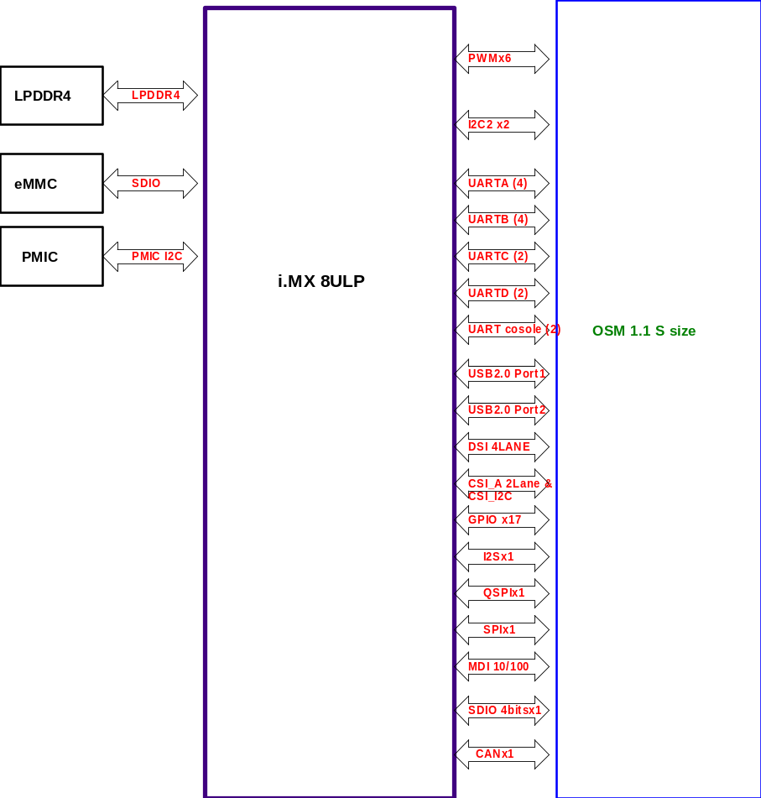
Figure 5 : Module Block Diagram

RMII Interface
ROM-2620 provide one 10/100 Mpbs Ethernet Controller (ENET), compliant with the IEEE802.3-2002 standard.
The interface used to connect an on-module MAC to an off-module PHY placed on the Carrier Board. Supported interfaces are RMII allowing speeds from 10 Mbit/s up to 100 Mbit/s.
The ROM-2620 Hardware Specification allows using 1.8 V as the I/O voltage on the MAC interface, SOC and Ethernet PHY.

Figure 6 : RMII MAC/PHY interface

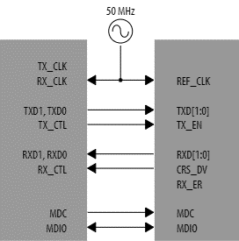

Table 4 Rom-2620 RMII Interface Pins out
Signal | CPU Pin-Out | OSM V1.1 | Description | I/O Level | Note
ETH_A_(S)(R)(G)MII_TXD0 | B2 | H15 | Transmit data bit 0 (transmitted first) port A | 1.8V | A35 domain  50 ohm impedance
ETH_A_(S)(R)(G)MII_TXD1 | B1 | G15 | Transmit data bit 1 port A | 1.8V | A35 domain  50 ohm impedance
ETH_A_(S)(R)(G)MII_RXD0 | D4 | K15 | Receive data bit 0 (received first) port A | 1.8V | A35 domain  50 ohm impedance
ETH_A_(S)(R)(G)MII_RXD1 | A2 | L15 | Receive data bit 1 port A | 1.8V | A35 domain  50 ohm impedance
ETH_A_(R)(G)MII_TX_CLK | B3 | J15 | Transmit clock port A | 1.8V | A35 domain  50 ohm impedance
ETH_A_(R)(G)MII_RX_DV(_ER) | D5 | M15 | Receive data valid port A | 1.8V | A35 domain  50 ohm impedance
ETH_A_(R)(G)MII_RX_ER | D6 | L16 | Receive error port A | 1.8V | A35 domain  50 ohm impedance
ETH_A_(R)(G)MII_TX_EN(_ER) | B4 | K16 | Transmit enable (Error) port A | 1.8V | A35 domain  50 ohm impedance
ETH_MDC | A4 | T16 | Management bus clock signal for Ethernet | 1.8V | A35 domain  50 ohm impedance
ETH_MDIO | E6 | T15 | Management bus data signal for Ethernet | 1.8V | A35 domain  50 ohm impedance
ETH_IOPWR | NA | M17 | ETH voltage. It is used to provide the IO  Voltage Level for all Ethernet interfaces. | 1.8V | From +VBUCK1_LSW4_CPU_1V8[2]

Note 2 : +VBUCK1_LSW1_CPU_1V8, +VBUCK1_1V8, and +VBUCK1_LSW4_CPU_1V8 PWR rails are come from the MOD that used for Carrier Board Power on sequence logic pull high and the Boot configs pull high. Not for power supply.

2.4.1 RMII signal layout guide
1. Ninety-degree trace should be avoided. We recommend that the traces turn at 45° angles as shown.
2. TXCLK (REF_CLK) is a high-speed (50MHz) signal; keep a 20mils spacing between clock and data signal
3. Match each RMII TX and RX group trace length to within 100 miles.
4. Route the RMII traces at 50 ohms impedance and use a stripline to reduce radiation.
5. Keep all RMII traces as short as possible.
6. All RMII traces should reference an unbroken ground or power plane.
7. Place the RC filter component close to the source of the reference clock in RMII mode.

2.4.2 LAN Signal Definitions
The RMII interface of the OSM module consists of TXD0/1, RXD0/1, ETH_A_RMII_TX_CLK, ETH_A_RMII_TX_EN, ETH_A_RMII_RX_ER, ETH_A_RMII_RX_DV, MDC and MDIO..etc. The carrier board should design the LAN PHY to be used to connect a 10/100BaseT RJ45 connector with integrated or external isolation magnetics to the carrier board.
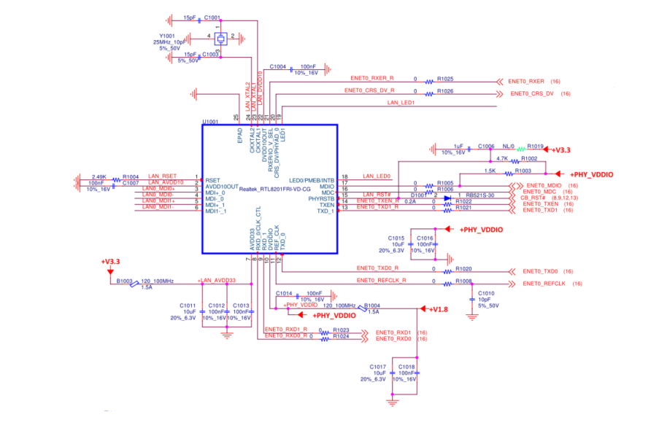

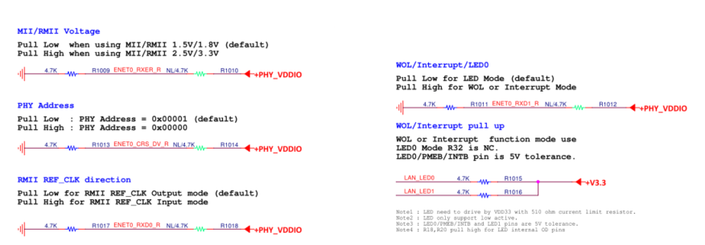

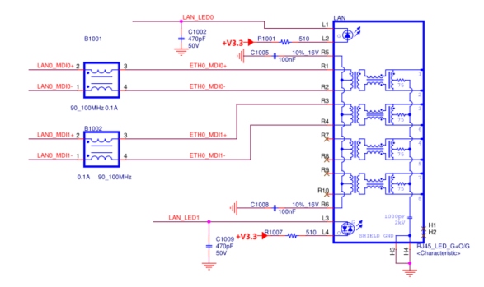

Figure 7 : ROM-ED91 Lan PHY schematic

2.4.3 LAN Implementation Guidelines
The most critical component in the LAN interface is the isolation magnetics connected directly to the MDI differential pair signals of the carrier board. It should be carefully qualified for Return Loss, Insertion Loss, Open Circuit Inductance, Common Mode Rejection, and Crosstalk Isolation to pass the IEEE conformance tests and EMI tests.
Even if an OSM module complies with the basic specifications set forth for IEEE certification, it's still possible that the overall system could fail IEEE testing because of poor quality or unsuitable external isolation magnetics module and/or improper PCB layout of the carrier board.

2.4.4 LAN Magnetics Modules
Traces routed from the RTL8201FR-VD to the 10/100M magnetics, and to the RJ-45 connector, should be as short as possible. The 12cm maximum length between the RTL8201FR-VD and magnetics is achievable only when there is no interference.
It is also very important to keep all differential pair signal traces (MDI0+/-, MDI1+/-, etc.) at matching lengths (within 25mil). MDI impedance is 50ohm common mode, 100ohm differential mode). The two traces of each pair should be placed close to each other since they are differential pair signals to each other and provide a strong canceling effect on noise.
The different differential pairs' specs should be more than 5 times the line width, and to minimize impedance mismatch, we recommend not using vias on the differential pairs.

Table 5 MDI interface
Name | Type | Pin No. | Description
MDI+[0]  MDI-[0] | IO | 3  4 | Transmit Output.  Differenial transmit output pair shared by 100Base-TX, 100Base-FX, and 10Base-T modes. When configured as 100Base-TX, output is an MLT-3 encoded waveform. When configured as 100Base-FX, the output is pseudo-ECL level.
MDI+[1]  MDI-[1] | IO | 5  6 | Receive Input  Differential receive input pair shared by 100Base-TX, 100Base-FX, and 10Base -T modes.

2.4.5 LAN Component Placement
When using RJ45 connectors without integrated magnetics, the discrete magnetics module has to be placed as close as possible to the RJ45 connector. The distance between the magnetics module and the RJ45 connector must be less than 1 inch. When implementing LAN, this distance requirement must be observed during the carrier board layout. Signal attenuation could cause data transfer problems for traces too long. Please check the LAN PHY design guideline.

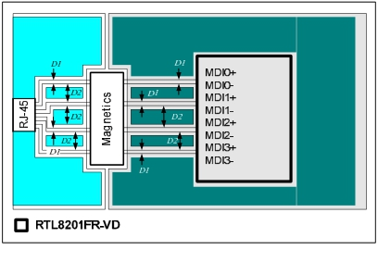

Figure 8 : Lan PHY MDI Signals

2.4.6 LAN Ground Plane Separation
The isolated separation between the analog ground plane and the digital ground plane is recommended. If this is not implemented correctly then insufficient ground plane partitioning could cause serious EMI emissions and degrade analog performance due to ground bounce noise.
The plane area underneath the magnetic module should be left empty. This free area is to keep transformer-induced noise away from the power and system ground planes.
The isolated ground, also called chassis ground, connects directly to the fully shielded RJ45 connector. For better isolation, it is also important to maintain a gap between chassis ground and system ground that is wider than 60mils. For ESD protection, a 3kV high voltage capability capacitor is recommended to connect to this chassis ground.

2.4.7 LAN Link Activity and Speed LED
The ROM-ED91 used RTL8201FR-VD that we suggest to pull high the LED pin with a 4.7KΩ resistor. This can provide the required high and low level to turn the LED off and on.

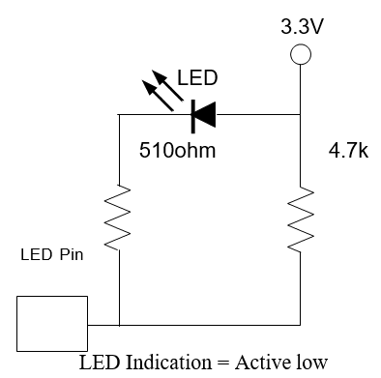

Figure 9 : LAN LED Circuit.

2.4.8 LAN Trace Length Guidelines

Table 6 MDI Trace Length Guidelines
Parameter | Main Route Guidelines | Note
Signal Group | GBE0_MDIx+, GBE0_MDIx-
Differential Impedance Target | 100 Ω ±10% 
Single End | 50Ω ±10%
Spacing between RX and TX pairs (inter-pair) (s) | Min. 5 times trace widths
Spacing between differential pairs  and high-speed periodic signals | Min. 50mils
Spacing between differential pairs  and low-speed non-periodic signals | Min. 5 times trace widths
Spacing between digital ground  and analog ground plane (between the magnetics Module and RJ45 connector) | Min. 50mils
LA | Carrier Board Length
Max length of LA | 4500mils
Length matching | Differential pairs (intra-pair): Max. ±10 mils
Reference Plane | GND referencing preferred.
Spacing from the edge of a plane | Min.50mils
Carrier Board Via Usage | Max. 2 vias.

2.4.9 Reference Ground Isolation and Coupling
The Carrier Board should maintain a well-designed analog ground plane around the components on the primary side of the transformer between the transformer and the RJ-45 receptacle. The analog ground plane is bonded to the shield of the external cable through the RJ-45 connector housing.

The analog ground plane should be coupled to the carrier’s digital logic ground plane using a capacitive coupling circuit that meets the ground plane isolation requirements defined in the 802.3-2005 specification. It is recommended that the Carrier Board PCB design maintain a minimum 30 mils gap between the digital logic ground plane and the analog ground plane.

It's recommended to place an optional GND to SHIELDGND connection near the RJ-45 connector to improve EMI and ESD capabilities.

USB
The USB (Universal Serial Bus) is a hot-pluggable general-purpose high-speed I/O standard for computer peripherals. The standard defines connector types, cabling, and communication protocols for interconnecting a wide variety of electronic devices. The USB 2.0 Specification defines data transfer rates as high as 480 Mbps (also known as High-Speed ​​USB). A USB host bus connector uses four pins: a power supply pin (5V), a differential pair (D+ and D- pins), and a ground pin. Additionally, a fifth pin, USB ID (mostly used in devices supporting USB-OTG), may also be used which indicates whether the device operates in Host mode or Client/Device mode.

OSM Modules support up to two independent USB 2.0 buses, designated USB A port and USB B port.

OSM USB A port can be configured as a host, client, or OTG port. OTG and client operation are optional. A common scenario for USB A is using it as an interface for the serial downloader for the SOC. USB Boot or client function in case of special boot configuration is specific to the SOC used on the module.

The ROM-2620 design the USB_B_ID on the module, so it can be like the USB A port design.

See OSM Hardware Specification for full Support Matrix of USB depending on the module size.

Table 7 Rom-2620 USB2.0 Interface Pins out

Contact Name | CPU Pin-Out | OSM 1.1V Definition Pin | Description | I/O Type | I/O Level | Note
USB_A_D_N | T2 | AB13 | USB differential data pairs for port A | I/O USB | USB
USB_A_D_P | T1 | AC14 | USB differential data pairs for port A | I/O USB | USB
USB_A_ID | D2 | AB14 | Input Contact to announce OTG device insertion on USB 2.0 port | I OD CMOS | 1.8V | A35 domain, Module PU 10k
USB_A_OC# | J6 | AC15 | USB over-current for port A | I OD CMOS | 1.8V | A35 domain, Module PU 10k
USB_A_VBUS | R2 | AB16 | USB port 0 port power detection | I USB VBUS 5V | USB VBUS 5V
USB_A_EN | F5 | AC16 | Power enable for USB VBUS voltage | O CMOS | 1.8V | A35 domain
USB_B_D_N | V2 | AB23 | USB differential data pairs for port B | I/O USB | USB
USB_B_D_P | V1 | AC22 | USB differential data pairs for port B | I/O USB | USB
USB_B_ID | E4 | AB22 | Input Contact to announce OTG device insertion on USB 2.0 port | I OD CMOS | 1.8V | A35 domain,  Module PU 10k
USB_B_OC# | H5 | AC21 | USB over-current for port B | I OD CMOS | 1.8V | A35 domain,  Module PU 10k
USB_B_VBUS | U5 | AB20 | USB port 0 port power detection | I USB VBUS 5V | USB VBUS 5V
USB_B_EN | F4 | AC20 | Power enable for USB VBUS voltage | O CMOS | 1.8V | A35 domain

2.5.1 USB A Client / Host direct from Module (USB 2.0)

Figure 8 shows a USB-OTG implementation on the USB A port terminated on a USB micro Type A/B connector.
USB A port also defines a serial download mode with the NXP UUU tool.
The ESD diodes should be placed close to the connector, and the USB traces routed as differential pairs in a “no stub” fashion – the traces should go through the pads of the ESD protection devices, without introducing a stub. If the client device is bus-powered, the Carrier can supply 5 V, 500mA power to the client device. The Module USB_A_EN signal controls the power switch IC, which in turn supplies power to a bus-powered client device. USB_A_OC# is an open drain output of the Carrier Board to the module and signals an overcurrent event. Per the USB specification, bus-powered USB 2.0 devices are limited to a maximum of 500 mA. The OCP IC limits the current and can stand an indefinite short circuit to GND. The current limiting is somewhat imprecise and kicks in between 500 mA and 1 A.
A Micro USB type A plug at the Carrier receptacle pulls the ID pin signal to the ground so that the Module acts as a Host. The ID will notice the CPU that sends the USB_A_PWR signal to turn on the power switch IC.
If A port is a client, the USB_A_ID should be floating. When the USB cable is inserted, the VBUS power should be supplied by the Host (PC or NB…etc). And then, the VBUS will make the USB_A_VBUS_DET have 5V to make the CPU USB PHY turn on. We suggest the USB_A_VBUS_DET pin should add a buffer to protect the CPU to avoid the voltage glitch.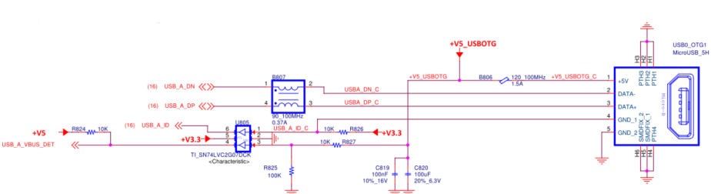

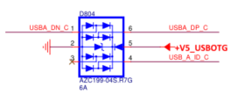
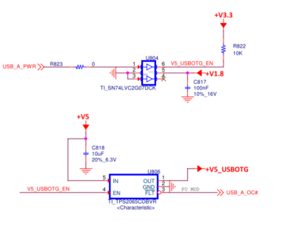
Figure 10 : Micro-USB circuit of ROM-ED91

2.5.2 USB B Host Mode
The ROM-2620 USB B port has the USB_B_ID pin when designer use the host mode that we need pull this pin to low (<1k ohm, or direct connected to GND).

- An implementation of a single USB Type A host port header is shown in the figure below.
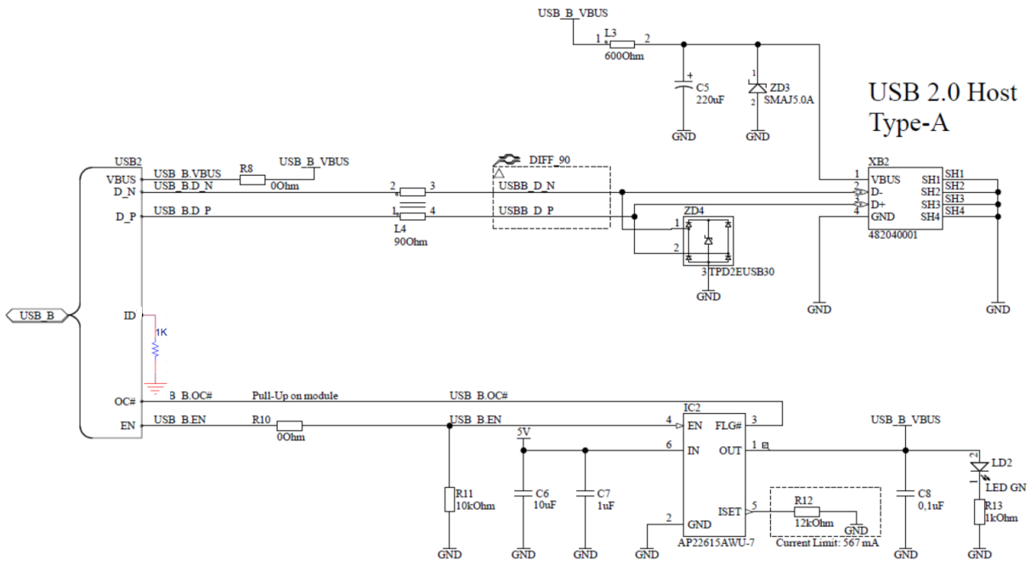
Figure 11 : USB 2.0 type A connector circuit

- Add the USB Hub, the USB_B_ID should be low (<1k ohm, or direct connected to GND).
The USB_B_VBUS_DET should connect to 5V on carrier board.
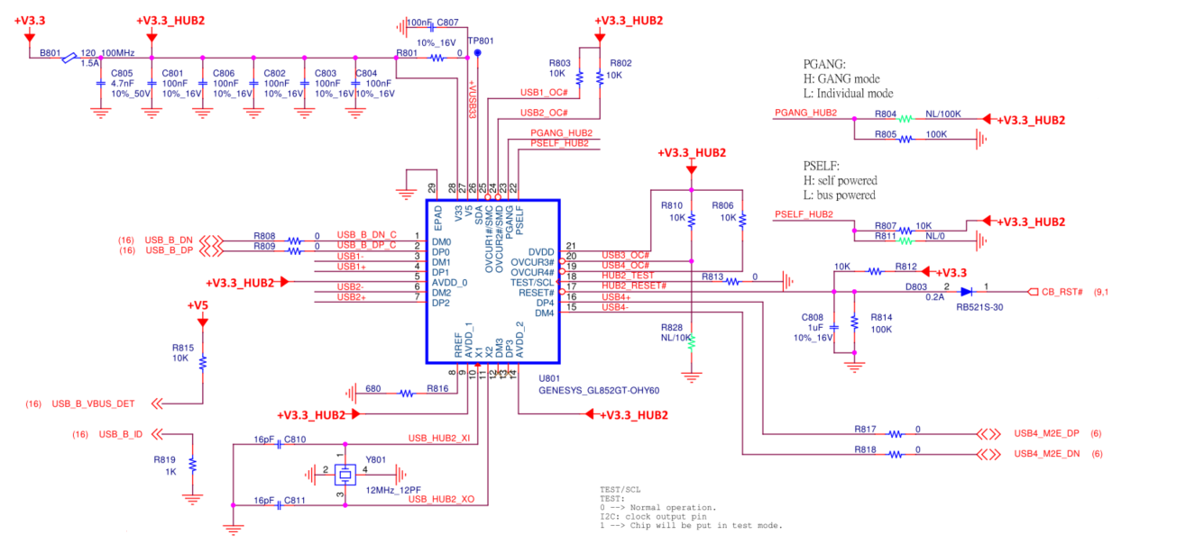
Figure 12 : USB 2.0 HUB circuit of ROM-ED91

2.5.3 USB2.0 Routing Guidelines
Use the following general routing and placement guidelines when laying out a new design. These guidelines help minimize signal quality and EMI problems.
- Do not route USB 2.0 traces under crystals, oscillators, clock synthesizers, magnetic devices, or ICs that use and/or duplicate clocks.
- Separate signal traces into similar categories, and route similar signal traces together (such as routing differential-pairs together).
- Keep USB 2.0 signals clear of the core logic set. High current transients are produced during internal state transitions and can be very difficult to filter out.
- Follow the 20 x h rule by keeping traces at least [20 x (height above the plane)] mils away from the edge of the plane (VCC or GND). For example: stack up, the height above the plane is 4.5 mils (0.114 mm). This calculates to a 90-mil (2.286-mm) spacing requirement from the edge of the plane. This helps prevent the coupling of the signal onto adjacent wires and also helps prevent free radiation of the signal from the edge of the PCB.
- Avoid stubs on high-speed USB signals because stubs cause signal reflections and affect signal quality. If a stub is unavoidable in the design, the total of all the stubs on a particular line should not be greater than 200 mils (5.08 mm).

2.5.4 USB 2.0 Port Power Delivery
The following is a suggested topology for the power distribution of VBUS to USB ports.
These circuits provide two types of protection during dynamic attach and detach situations on the bus: inrush current limiting (droop) and dynamic detach flyback protection. These two types require both bulk capacitances (droop) and filtering capacitance (for dynamic detach flyback voltage filtering). Recommends the following:
- Minimize the inductance and resistance between the coupling capacitors and the USB ports.
- Place capacitors as close as possible to the port and the power-carrying traces should be as wide as possible, preferably, a plane.
- Make the power-carrying traces wide enough that the system fuse blows on an overcurrent event. If the system fuse is rated at 1 A, then the power-carrying traces should be wide enough to carry at least 1.5 A.

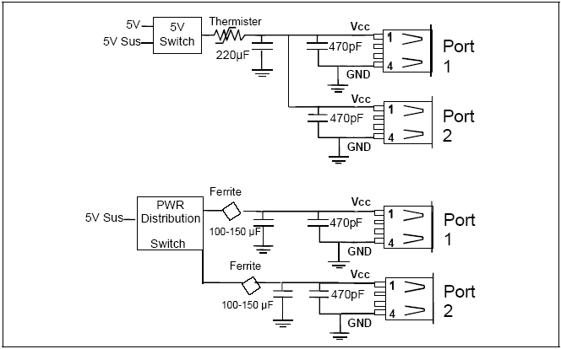

Figure 13 : USB 2.0 Good Downstream Power Connection

2.5.5 USB Client Considerations
Precautions at the carrier board level must take to protect against voltage spikes and ESD to ensure robust operation of the host detection circuitry after multiple connect/disconnect events. A clamping diode may be used to minimize ESD, and a bulk capacitor should be placed on +5V USB client rail to avoid excessive voltage spikes.

2.5.6 USB2.0 Trace Length Guidelines

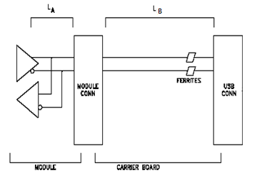
Figure 14 : Topology for USB2.0

Table 8 USB2.0 Trace Length Guidelines
Parameter | Main Route Guidelines | Note
Signal Group
Differential Impedance Target | 90 Ω ±10%
Single End | 50Ω ±10%
Spacing between pairs-to-pairs  (inter-pair) (s) | Min. 20 mils
Spacing between differential  pairs and high-speed periodic signals | Min. 50 mils
Spacing between differential  pairs and low-speed non-periodic signals | Min. 20 mils
LA | Please see the ROM-2620 module Layout Checklist
LB | Carrier Board Length
Max length of LA+LB | As short as possible
Length matching | Differential pairs (intra-pair): Max. ±5 mils
Reference Plane | GND referencing preferred
Spacing from the edge of a plane | Min. 40mils
Carrier Board Via Usage | Try to minimize the number of vias

2.5.7 USB Connector EMI / ESD Protection

USB2.0:
Testing has shown that common mode chokes can provide the required noise attenuation. The design should include a common mode choke footprint to provide a stuffing option in the event the choke is needed to pass EMI testing. The below figure shows the schematic of a typical common mode choke and ESD suppression components. Place the choke as close as possible to the USB connector signal pins.
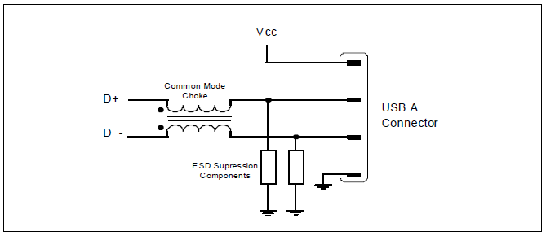
Figure 15 : USB 2.0 Common Mode Chokes and ESD

Common mode chokes distort full-speed and high-speed signal quality. As the common-mode
Impedance increases the distortion increases, therefore test the effects of the common mode choke on full speed and high-speed signal quality. Common mode chokes with a target impedance of 90 Ω, at 100 MHz, generally provide adequate noise attenuation.

Finding a common mode choke that meets the designer’s needs is a two-step process:
- Choose a part with the impedance value that provides the required noise attenuation. This is a function of the electrical and mechanical characteristics of the part chosen and the frequency and strength of the noise present on the USB traces that should be suppressed.
- After obtaining a part that gives passing EMI results, the second step is to test the effect this part has on signal quality. Higher impedance common mode chokes generally have a greater damaging effect on signal quality, so care must be used when increasing the impedance without doing thorough testing. Thorough testing means that the signal quality must be checked for low-speed, full-speed, and high-speed USB operation.

Further common mode choke information can be found on the high-speed USB Platform Design Guides available at www.usb.org.

To improve the EMI behavior of the USB interface, the design should include common mode chokes, which have to be placed as close as possible to the USB connector signal pins.
Common mode chokes can provide required noise attenuation but they also distort the signal quality of full-speed and high-speed signaling. Therefore, common mode chokes should be chosen carefully to meet the requirements of the EMI noise filtering while retaining the integrity of the USB signals on the Carrier Board design.

To protect the USB host interface of the Module from over-voltage caused by electrostatic discharge (ESD) and electrical fast transients (EFT), low capacitance steering diodes and transient voltage suppression diodes have to be implemented on the Carrier Board design.

SDIO Interface
SDIO (Secure Digital I/O) provides an easy-to-implement solution for high-speed data I/O combined with low power consumption. SDIO cards are fully compatible with SD memory cards. Since SD cards can (usually) be inserted and removed by the user, it is important to implement ESD protection on all the SD lines.
The ROM-2620 used the module's OSM SDIO A port 4-bit SDIO interface. The SDIO I/O voltage of ROM-2620 is fixing 1.8V.

Table 9 Rom-2620 SDIO Interface Pins out
Contact Name | CPU Pin-Out | OSM 1.1V Definition Pin | Description | I/O Type | I/O Level | Note
SDIO_A_CMD | A8 | E20 | SDIO A Command/Response. This signal is used for card initialization and for command transfers. During initialization mode this signal is open drain. During command transfer this signal is in push-pull mode. | I/O CMOS | 1.8V | A35 domain
SDIO_A_CLK | D10 | F21 | SDIO A Clock. With each cycle of this signal a one-bit transfer on the command and each data line occurs. | O CMOS | 1.8V | A35 domain
SDIO_A_D0 | B10 | G20 | SDIO A Data lines. These signals operate in push-pull mode. | I/O CMOS | 1.8V | A35 domain
SDIO_A_D1 | A10 | G21 | SDIO A Data lines. These signals operate in push-pull mode. | I/O CMOS | 1.8V | A35 domain
SDIO_A_D2 | B8 | H20 | SDIO A Data lines. These signals operate in push-pull mode. | I/O CMOS | 1.8V | A35 domain
SDIO_A_D3 | D9 | H21 | SDIO A Data lines. These signals operate in push-pull mode. | I/O CMOS | 1.8V | A35 domain
SDIO_A_CD# | N5 | J21 | SDIO A Card Detect. This signal indicates when a SDIO/MMC card is present.  Active Low | I OD CMOS | 1.8V | A35 domain  PU 10k on module
SDIO_A_WP | P1 | D20 | SDIO A Write Protect. This signal denotes the state of the write- protect tab on SD cards.  High protected. | I OD CMOS | 1.8V | A35 domain  PU 10k on module, Tie to GND on carrier, if not used
SDIO_A_PWR_EN | N6 | D21 | SDIO A Power Enable. This signal is used to enable the power being supplied to a SD/MMC card device. | O CMOS | 1.8V | A35 domain [3]
SDIO_A_IOPWR | NA | C20 | SDIO A Voltage. It is used to provide the IO Voltage Level | P | 1.8V | A35 domain  i.MX8ULP don't support Voltage IO select

Note 3 : If boot from SD card, the SDIO_A_PWR_EN should pull up to 1.8V with 1K ohm on carrier board.

2.6.1 SDIO for SD card boot device or storage
ROM-2620 can support SD card booting. If the designers want to use this function, the Carrier Board should add a level shift from 1.8V to 3.3V, and the clock will be less than 50MHz. Designers should ensure that SD VDD should be turned on by CARRIER_PWR_EN as soon as possible (less than 12ms). Before the CPU is controlled, SDIO_A_PWR_EN needs to pull high to 1.8V with 1K ohm on the Carrier board to enable SD card power.

If storage is used, the design is the same as described before, except that VDD can be controlled by SDIO_A_PWR_EN.
ROM-2620 won’t use the SDIO_x_IOPWR interfaces. Do not use SDIO_x_IOPWR to supply an SD Card.

Note 4 : Do not connect 1.8V to the VDD of SD-Card. 3.3V is the only allowed voltage for standard High-voltage cards.

Note 5 : The SDIO_x_WP has a Pull-Up 10K ohm on the OSM Module. If not considered at the Carrier board the micro-SD/ SD card will be automatically write-protected. To enable writing to the card it is suggested to use a pull-down resistor with a value of 1 kΩ or below on the Carrier.

Note 6 : Some SD card connectors do not offer a card detect switch. If the signal SDIO_x_CD# is interpreted by the Module software it is necessary to pull this signal to GND at the Carrier with a pull-down resistor of 1 kΩ or below.

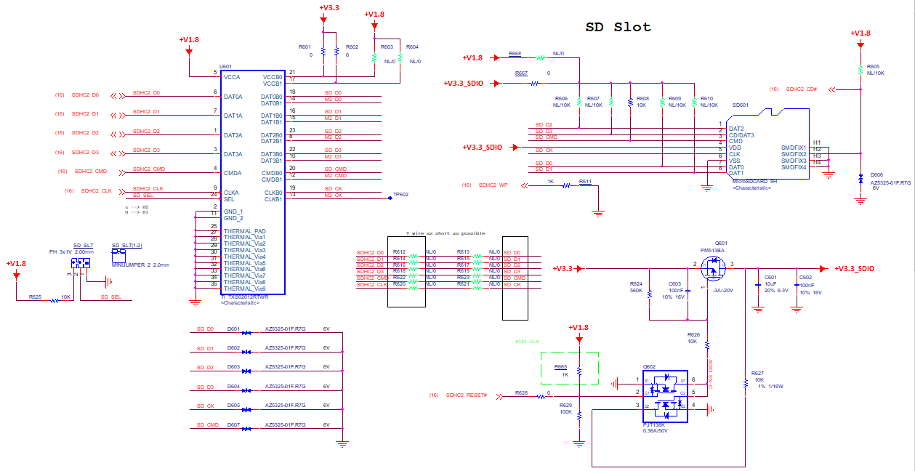

Figure 16 : The SDIO circuit of the ROM-ED91

2.6.2 SDIO for the Wireless Modules.

Depending on the OSM Module the SDIO interface can be used to connect to a wireless module (WiFi, Bluetooth). There are a lot of vendors with different types and solutions.

The I/O voltage of the SDIO module should be considered to decide whether a level shifter is needed or not.

2.6.3 SDIO Interface Routing Guidelines

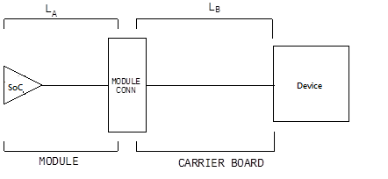
Figure 17 : Topology for SDIO

Table 10 SDIO Trace Length Guidelines
Parameter | Main Route Guidelines | Note
Signal Group | SDIO
Single End | 50Ω ±10%
CMD/Data/DATA to CLK Maximum Pin to Pin  Length Mismatch | +/- 10mils
Main Route segment for  CMD/Data/CLK | Minimum Trace Spacing Between Others SD Card and  Interface Signals 15 mils
Spacing to Others Signal Group | Min. 15mils
LA | Please see the ROM-2620 Layout Checklist
LB | Carrier Board Length
Max length of LA+LB | As short as possible
Length matching | Data to Clock must be matched within +/- 50mils
Reference Plane | GND referencing preferred.  Min 20-mil trace edge-to-major plane edge spacing.

I2S Interface
The I2S (Inter IC Sound) bus specification was initially released in 1986 by Philips (NXP) and later revised in 1996. I2S is a synchronous serial bus used for interfacing digital audio devices such as Audio CODECs and DSP chips. Generally, PCM audio data is transmitted over the I2S interface. The I2S bus may have a single bidirectional data line or two separate data lines. The signals constituting the I2S bus are a serial clock/ bit clock (output from the master), a left-right clock (output from the master) that indicates the channel being transmitted, and a single bidirectional data line or two data lines - one input and one output. An OSM Module can generally be configured as an I2S master or slave.
ROM-2620 used the port A be the I2S master and the ROM-ED91 used the pin heard to combine the audio codec board. The I2C is used for chip setup parameters.

Table 11 Rom-2620 I2S Interface Pins out
Contact Name | CPU  Pin-Out | OSM 1.1V Definition Pin | Description | I/O Type | I/O Level | Note
I2S_A_DATA_IN | A14 | V21 | I2S A Digital audio Input | I/O CMOS | 1.8V | A35 domain
I2S_A_DATA_OUT | E13 | W21 | I2S A Digital audio Output | I/O CMOS | 1.8V | A35 domain
I2S_MCLK | A12 | V18 | Master clock output to I2S codec(s) | I/O CMOS | 1.8V | A35 domain
I2S_LRCLK | D13 | W18 | I2S Left & Right synchronization clock | I/O CMOS | 1.8V | A35 domain
I2S_BITCLK | B14 | W20 | I2S Digital audio clock | I/O CMOS | 1.8V | A35 domain

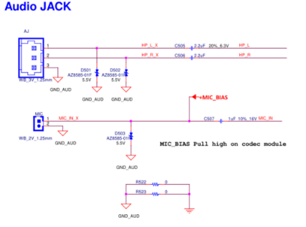
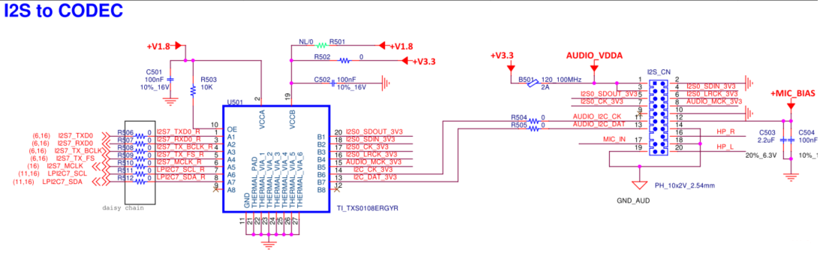
Figure 18 : I2S circuit of ROM-ED91

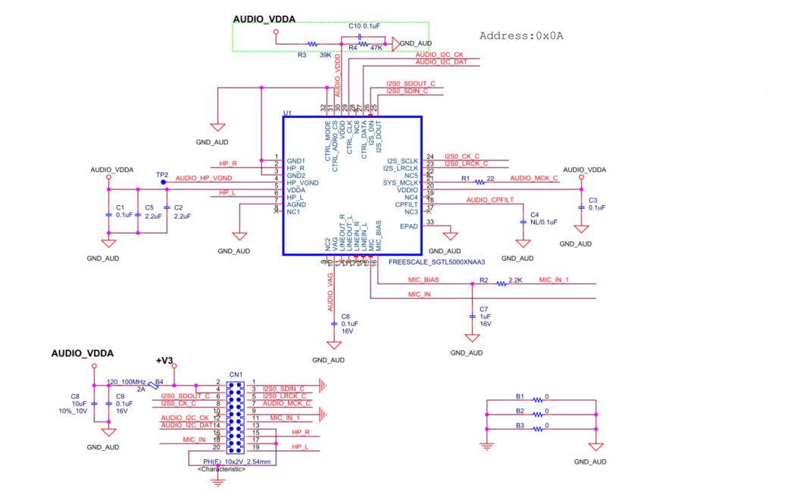
Figure 19 : Audio Codec circuit SGTK5000

2.7.1 Audio Routing Guidelines
The implementation of proper component placement and routing techniques will help to ensure that the maximum performance available from the codec is achieved. Routing techniques that should be observed include properly isolating the codec, associated audio circuitry, analog power supplies, and analog ground planes from the rest of the Carrier Board. This includes split planes and the proper routing of signals not associated with the audio section.

The following is a list of basic recommendations:
- Traces must be routed with a target impedance of 50Ω with an allowed tolerance of ±15%.
- Ground return paths for the analog signals must be given special consideration.
- Digital signals routed in the vicinity of the analog audio signals must not cross the power plane split lines. Locate the analog and digital signals as far as possible from each other.
- Partition the Carrier Board with all analog components grouped in one area and all digital components in another.
- Keep digital signal traces, especially the clock, as far as possible from the analog input and voltage reference pins.
- Provide separate analog and digital ground planes with the digital components over the digital ground plane, and the analog components, including the analog power regulators, over the analog ground plane. The split between the planes must be a minimum of 0.05 inch wide.
- Route analog power and signal traces over the analog ground plane.
- Route digital power and signal traces over the digital ground plane.
- Position the bypassing and decoupling capacitors close to the IC pins with wide traces to reduce impedance.
- Place the crystal or oscillator (depending on the codec used) as close as possible to the codec. (HDA implementations generally do not require a crystal at the codec)
- Do not completely isolate the analog/audio ground plane from the rest of the Carrier Board ground plane. Provide a single point (0.25 inch to 0.5 inches wide) where the analog/isolated ground plane connects to the main ground plane. The split between the planes must be a minimum of 0.05 inch wide.
- Any signals entering or leaving the analog area must cross the ground split in the area where the analog ground is attached to the main Carrier Board ground. That is, no signal should cross the split/gap between the ground planes, because this would cause a ground loop, which in turn would greatly increase EMI emissions and degrade the analog and digital signal quality.

2.7.2 Audio Trace Length Guidelines
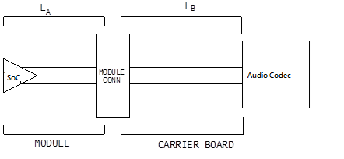
Figure 20 : Topology for Audio

Table 12 Audio Trace Length Guidelines
Parameter | Main Route Guidelines | Note
Signal Group | Audio
Single End | 50Ω ±15%
Nominal Trace Space within  Audio Signal Group | Min. 15mils
Spacing to Others Signal Group | Min. 20mils
LA | Please see the OSM module’s Layout Checklist
LB | Carrier Board Length
Max length of LA+LB | As short as possible
Length matching | Data to Clock must be matched within 100mils
Reference Plane | GND referencing preferred.  Min 20-mil trace edge-to-major plane edge spacing.

MIPI-DSI
ROM-2620 modules can support one MIPI DSI (Display Serial Interface). DSI is a high-speed differential bus and includes one clock lane and up to four data lanes. There is no AC coupling required.
VDD and Backlight signals are not specified by the OSM Module Hardware Specification.

Table 13 Rom-2620 MIPI-DSI Interface Pins out

Contact Name | CPU Pin-Out | OSM 1.1V Definition Pin | Description | I/O Type | I/O Level | Note
DSI_DATA0_N | E22 | AB11 | DSI differential output (point to point) | O LVDS D-PHY |  | [7][8]
DSI_DATA0_P | F22 | AB10 | DSI differential output (point to point) | O LVDS D-PHY |  | [7][8]
DSI_DATA1_N | A24 | AC9 | DSI differential output (point to point) | O LVDS D-PHY |  | [7][8]
DSI_DATA1_P | B24 | AC8 | DSI differential output (point to point) | O LVDS D-PHY |  | [7][8]
DSI_DATA2_N | E24 | AC6 | DSI differential output (point to point) | O LVDS D-PHY |  | [7][8]
DSI_DATA2_P | F25 | AC5 | DSI differential output (point to point) | O LVDS D-PHY |  | [7][8]
DSI_DATA3_N | D21 | AB5 | DSI differential output (point to point) | O LVDS D-PHY |  | [7][8]
DSI_DATA3_P | D22 | AB4 | DSI differential output (point to point) | O LVDS D-PHY |  | [7][8]
DSI_CLOCK_N | E21 | AB8 | DSI differential clock output (point to point) | O LVDS D-PHY |  | [7][8]
DSI_CLOCK_P | F21 | AB7 | DSI differential clock output (point to point) | O LVDS D-PHY |  | [7][8]
DISP_VDD_EN /GPIO_C_4 | D12 | F3 | Primary Display power enable, active high | O CMOS | 1.8V
DISP_BL_EN /GPIO_C_5 | E12 | F4 | Primary Display backlight enable, active high | O CMOS | 1.8V
DISP_BL_PWM /PWM_0 | B12 | E18 | Primary Display brightness control through pulse width modulation | O CMOS | 1.8V

Note 7: The ROM-2620 MIPI-DSI differential signals are 100 ohm (+/- 10%).
Note 8: Carrier Board MIPI-DSI trace length needs to compensate for the Module mismatch.

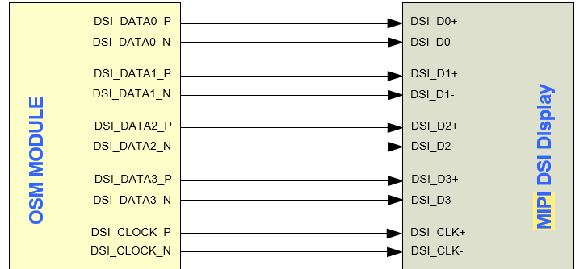

Figure 21 : DSI diagram.

Table 14 DSI Trace Length Guidelines
Parameter | Main Route Guidelines | Note
Signal Group | MIPI-DSI
Differential Impedance Target | 100Ω ±10%
Single End | 50Ω ±10%
Signal length to the connector | 4”
Spacing between pair to pairs  (inter-pair) (s) | Min. 20 mils
Spacing between differential pairs and  high-speed periodic signals | Min. 30 mils
Spacing between differential pairs and  low-speed non-periodic signals | Min. 20 mils
Module length | Please see the OSM module’s Layout Checklist
Carrier Board | Carrier Board Length
Max length of LA+LB | As short as possible
Length matching | Differential pairs (intra-pair): Max. ±2 mils  Clock and data pairs (inter-pair): Max. ±50 mils
Reference Plane | GND referencing preferred
Spacing from the edge of a plane | Min. 40mils
Carrier Board Via Usage | Max. of 2 vias per line.

2.8.1 MIPI-DSI to LVDS
The primary function of this chip is DSI-to-LVDS Bridge, enabling video streaming output over DSI link to drive LVDS-compatible display panels. Please contact the Bridge IC vendor and check the specifications to design it.

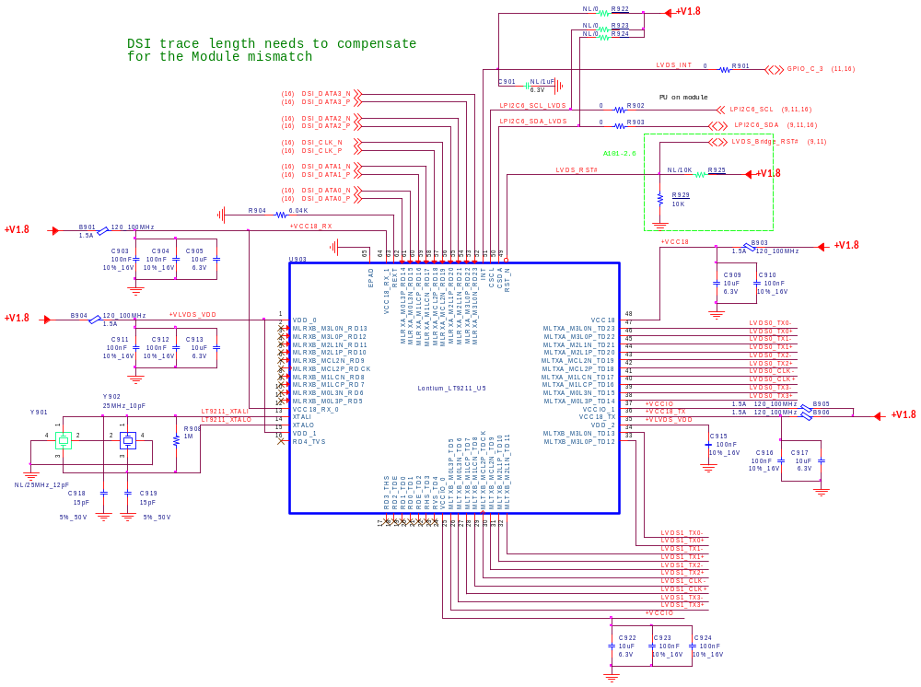
Figure 22 : ROM-ED91 DSI to LVDS circuit

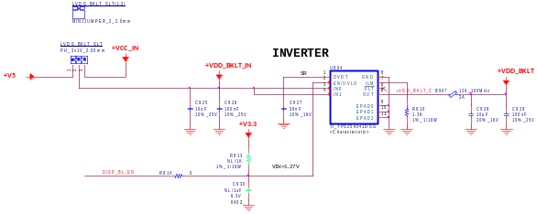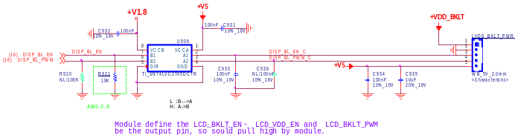
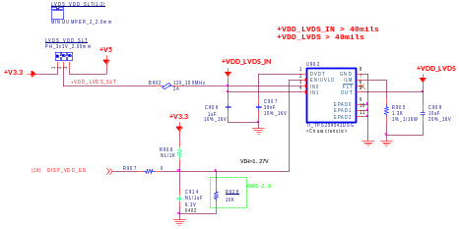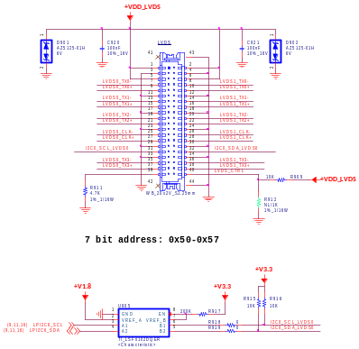

Figure 23 : ROM-ED91 VDD and backlight circuit

2.8.2 LVDS Trace Length Guidelines

Table 15 LVDS Trace Length Guidelines
Parameter | Main Route Guidelines | Note
Signal Group | LVDS
Differential Impedance Target | 100Ω ±10%
Single End | 50Ω ±10%
Spacing between pair to pairs  (inter-pair) (s) | Min. 20 mils
Spacing between differential pairs and  high-speed periodic signals | Min. 30 mils
Spacing between differential pairs and  low-speed non-periodic signals | Min. 20 mils
Max length | Carrier Board Length as short as possible
Length matching | Differential pairs (intra-pair): Max. ±2 mils  Clock and data pairs (inter-pair): Max. ±50 mils
Reference Plane | GND referencing preferred
Spacing from the edge of a plane | Min. 40mils
Carrier Board Via Usage | Max. of 2 vias per line.

MIPI-CSI Interface Signals
ROM-2620 modules support 2 data lanes of camera. Please check the MIPI-CSI signal definition and Pinout.

Table 16 ROM-2620 MIPI-CSI Interface Pins out
Contact Name | CPU Pin-Out | OSM 1.1V Definition Pin | Description | I/O Level
CSI_DATA0_N | B23 | C1 | CSI differential input (point to point) | I LVDS D-PHY/ I LVDS M-PHY
CSI_DATA0_P | B22 | B1 | CSI differential input (point to point) | I LVDS D-PHY / I LVDS M-PHY
CSI_DATA1_N | B19 | A2 | CSI differential input (point to point) | I LVDS D-PHY / I LVDS M-PHY
CSI_DATA1_P | B18 | A3 | CSI differential input (point to point) | I LVDS D-PHY / I LVDS M-PHY
CSI_CLOCK_N | A20 | B3 | CSI differential clock input (point to point) | I LVDS D-PHY
CSI_CLOCK_P | B20 | B4 | CSI differential clock input (point to point) | I LVDS D-PHY
CAM_MCK | NA | C2 | Master clock output | Used OSC24M [9]
I2C_CAM_SDA / CSI_TX_N | AG2 | C3 | I2C data for serial camera data support link or differential data lane | I/O  OD CMOS  1.8V
I2C_CAM_SCL / CSI_TX_P | AF4 | C4 | I2C clock for serial camera data support link or differential data lane | O  OD CMOS  1.8V
CAM_PWR / GPIO_C_6 | F12 | G3 | Camera 0 Power Enable, active high output. | O CMOS  1.8V
CAM_RST# / GPIO_C_7 | B11 | G4 | Camera 0 reset, active low output | O CMOS  1.8V

Note 9 : Carrier Board should add 24M oscillator be the CAM_MCK (1.8V).

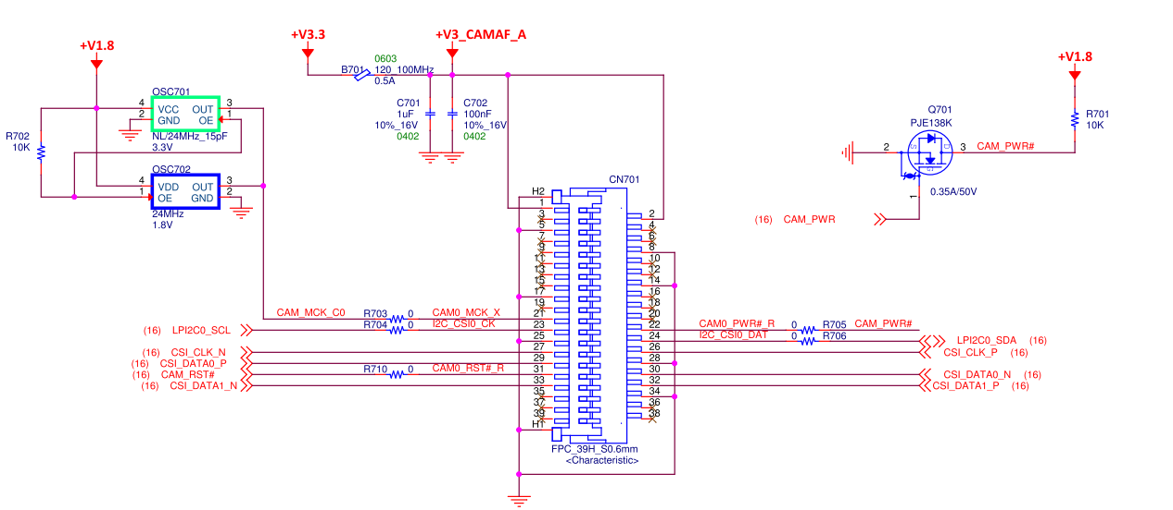
Figure 24 : ROM-ED91 Camera CSI connector design.

General purpose input/output

Table 17 Rom-2620 GPIO Interface Pins out
Contact Name | CPU Pin-Out | OSM 1.1V Definition Pin | Description | I/O Level | Note
GPIO_A_0 | AF18 | D17 | General purpose I/O | 1.8V | M33 domain
GPIO_A_1 | AJ16 | E17 | General purpose I/O | 1.8V | M33 domain
GPIO_A_2 | AE17 | F17 | General purpose I/O | 1.8V | M33 domain
GPIO_A_3 | AJ18 | G17 | General purpose I/O | 1.8V | M33 domain
GPIO_A_4 | AF17 | H17 | General purpose I/O | 1.8V | M33 domain
GPIO_A_5 | AF21 | J17 | General purpose I/O | 1.8V | M33 domain
GPIO_A_6/SPI_A_CS1# | AF20 | K17 | General purpose I/O | 1.8V | Dual function: SPI_A_CS1#  M33 domain
GPIO_A_7/SPI_B_CS1# | AH23 | L17 | General purpose I/O | 1.8V | Dual function: SPI_B_CS1#  M33 domain
GPIO_B_0 | AF22 | D19 | General purpose I/O | 1.8V | M33 domain
GPIO_B_1 | AJ24 | E19 | General purpose I/O | 1.8V | M33 domain
GPIO_B_2 | AE22 | F19 | General purpose I/O | 1.8V | M33 domain
GPIO_B_3 | AH24 | G19 | General purpose I/O | 1.8V | M33 domain
GPIO_B_4 | AD22 | H19 | General purpose I/O | 1.8V | M33 domain
GPIO_B_5 | AE24 | J19 | General purpose I/O | 1.8V | M33 domain
GPIO_B_6 | AD12 | K19 | General purpose I/O | 1.8V | M33 domain
GPIO_B_7 | AH11 | L19 | General purpose I/O | 1.8V | M33 domain
GPIO_C_0 | D14 | D3 | General purpose I/O | 1.8V | A35 domain
GPIO_C_1 | B15 | D4 | General purpose I/O | 1.8V | A35 domain
GPIO_C_2 | H6 | E3 | General purpose I/O | 1.8V | A35 domain
GPIO_C_3 | C2 | E4 | General purpose I/O | 1.8V | A35 domain
GPIO_C_4/DISP_VDD_EN | D12 | F3 | General purpose I/O | 1.8V | Dual function: DISP_VDD_EN  A35 domain
GPIO_C_5/DISP_BL_EN | E12 | F4 | General purpose I/O | 1.8V | Dual function: DISP_BL_EN  A35 domain
GPIO_C_6/CAM_PWR | F12 | G3 | General purpose I/O | 1.8V | Dual function: CAM_PWR  A35 domain
GPIO_C_7/CAM_RST# | B11 | G4 | General purpose I/O | 1.8V | Dual function: CAM_RST#  A35 domain

Note 10 : During the system reset, GPIO defaults to Hi-Z. Before software can control the GPIO, the designer should ensure that the carrier board control signal should be low or high during the reset state.

CAN Interface
The CAN (“Controller Area Network”) bus is a differential half duplex data bus used in automotive and industrial settings. A CAN bus uses shielded or unshielded twisted differential pair wiring, terminated in with a differential impedance of 120 Ω at the endpoints of the bus. Nodes on the bus are arranged in daisy-chain fashion, although stubs of up to 0.3 meters are allowed at each node. The standard allows data rates of up to 1 Mbps, with a maximum bus length of 40 meters at that rate. Various slower rates are defined, along with longer and longer bus lengths allowed as the data rates go down. A bus rate of 250 kbps is common use in automotive application.
The two lines in a CAN twisted pair are referred to as CAN_H and CAN_L (for CAN High and CAN Low). There are two bus states on the CAN physical layer: the Dominant state and the Recessive state. In the Dominant state, CAN_L is pulled to GND through an open drain driver and CAN_H is pulled to the CAN Vcc through an open drain driver. In the Recessive state, CAN_L and CAN_H are not actively driven and they are pulled to a voltage of (Vcc / 2) by passive components. Hence the CAN bus is essentially a differential open-drain bus. On the system logic side of a CAN transceiver, the CAN Dominant state is a logic low and the Recessive state a logic high.
The OSM specification allows for up to two logic level CAN ports. The ports run at the Module I/O voltage (typically 1.8 V) and consist of an asynchronous CAN TX line and an RX line from and to the OSM Module CAN protocol controller.
A Carrier based CAN transceiver is required to provide a CAN bus from the Module signals. CAN PHYs are available from Texas Instruments, On Semiconductor, NXP, Microchip and numerous other vendors. The logic interface for CAN PHYs is typically suited for 3.3 V or 5V logic I/O, so level translation is required.
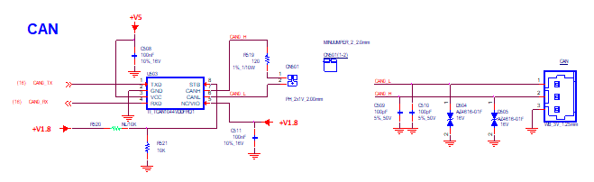

Figure 25 : ROM-ED91 Can bus circuit

2.11.1 CAN interface Signal Definitions

Table 18 Rom-2620 CAN Bus Interface Pins out
Contact Name | CPU Pin-Out | OSM 1.1V Definition Pin | Description | I/O Level | Note
CAN_A_TX | AH6 | AC17 | CAN port A Transmit output | 1.8V | M33 domain, 50 ohm impedance
CAN_A_RX | AD8 | AB17 | CAN port A Receive input | 1.8V | M33 domain, 50 ohm impedance

2.11.2 Interface Routing Guidelines
It should be routed as a differential pair signal with 120 Ohm differential impedance. The end points of CAN bus should be terminated with 120 Ohms or with 60 Ohms from the CAN_H line and 60 Ohms from the CAN_L line to the CAN Bus reference voltage. Check your CAN transceiver application notes for further details on termination.

2.11.3 Interface Trace Length Guidelines

Figure 26 : Topology for CAN Interface

Table 19 CAN Trace Length Guidelines
Parameter | Main Route Guidelines | Note
Signal Group | CAN interface
Single End | NA
Nominal Trace Space within SPI  Signal Group | Min. 10mils
Spacing to Others Signal Group | Min. 15mils
LA | ASAP
LB | Carrier Board Length
Max length of LA+LB | NA

Serial Peripheral Interface Bus
The SPI (Serial Peripheral Interface) is a full duplex synchronous bus supporting a single master and multiple slave devices. The SPI bus consists of a serial clock line (generated by the master); data output line from the master; a data input line to the master and one or more active low chip select signals (output from the master). OSM Modules running a 1.8 V I/O interface on all three SPI interfaces.
The OSM Module will always be the SPI master.

2.12.1 SPI Signal Definition
Each SPI device requires a chip select, a clock, a data in line and a data out line. The device I/O level must of course be compatible with the OSM Module I/O level of 1.8 V.

Table 20 Rom-2620 SPI Interface Pins out

Contact Name | CPU Pin-Out | OSM 1.1V Definition Pin | Description | I/O Level | Note
SPI_B_SDI | AH20 | Y22 | SPI B Serial Data Input | I CMOS 1.8V | M33 domain, 50 ohm impedance
SPI_B_SDO | AE21 | Y23 | SPI B Serial Data Output | O CMOS 1.8V | M33 domain, 50 ohm impedance
SPI_B_CS0# | AD21 | AA23 | SPI B Master Chip Select 0 | O CMOS 1.8V | M33 domain, 50 ohm impedance
SPI_B_CS1# / GPIO_A_7 | AH23 | L17 | SPI B Master Chip Select 1 | O CMOS 1.8V | M33 domain, 50 ohm impedance
SPI_B_SCK | AJ22 | Y21 | SPI B Serial Data Clock | O CMOS 1.8V | M33 domain, 50 ohm impedance

2.12.2 SPI Trace Length Guidelines

Figure 27 : Topology for SPI

Table 21 SPI Trace Length Guidelines
Parameter | Main Route Guidelines | Note
Signal Group | SPI
Single End | 50Ω ±15%
Nominal Trace Space within SPI  Signal Group | Min. 10mils
Spacing to Other Signal Group | Min. 15mils
LA | Please see the OSM module’s Layout Checklist
LB | Carrier Board Length
Max length of LA+LB | As short as possible
DATA to CLK Maximum Pin to Pin  Length Mismatch | Max. 250mils
Via Usage | Try to minimize the number of vias

QSPI
A Queued Serial Peripheral Interface (QSPI; see also Quad SPI) is a type of SPI controller that uses a data queue to transfer data across the SPI bus.
The SPI flash is connected to a dedicated QSPI unit of the CPU via CLK, DQ0, DQ1, DQ2, DQ3, and nCS pins.
Table 22 Rom-2620 QSPI Interface Pins out
Contact Name | CPU Pin-Out | OSM 1.1V Definition Pin | Description | I/O Level | Note
SPI_A_SDI_(IO0) | AH22 | U15 | SPI A Serial Data Input | 1.8V | M33 domain, 50 ohm impedance
SPI_A_SDO_(IO1) | AJ20 | V15 | SPI A Serial Data Output | 1.8V | M33 domain, 50 ohm impedance
SPI_A_/WP_(IO2) | AD18 | W16 | SPI A Write Protect | 1.8V | M33 domain, 50 ohm impedance
SPI_A_/HOLD_(IO3) | AH19 | W15 | SPI A Suspends Serial Input | 1.8V | M33 domain, 50 ohm impedance
SPI_A_CS0# | AH18 | Y15 | SPI A Master Chip Select 0 | 1.8V | M33 domain, 50 ohm impedance
SPI_A_CS1# / GPIO_A_6 | AF20 | K17 | SPI A Master Chip Select 1 | 1.8V | M33 domain, 50 ohm impedance
SPI_A_SCK | AE18 | U16 | SPI A Serial Data Clock | 1.8V | M33 domain, 50 ohm impedance
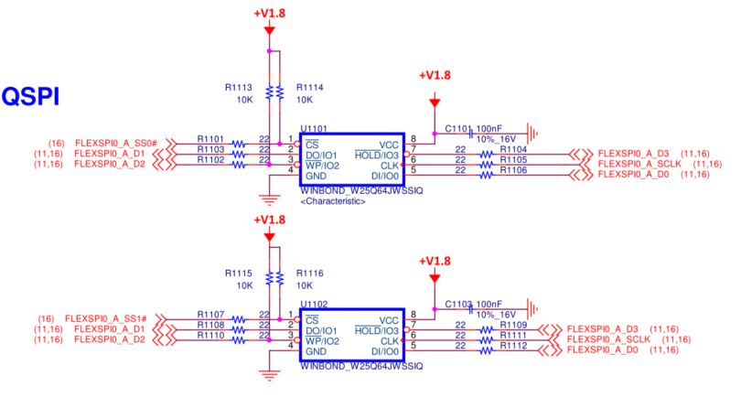

Figure 28 : ROM-ED91 QSPI circuit

General Purpose I2C Bus Interface
The I2C bus is a versatile low bandwidth multi-drop bus originally defined by Philips (now NXP). It is a two-wire bus (clock and data) that relies on open-drain drivers and passive pull-ups. The bus can be single-master or multi-master. OSM Modules support two I2C interfaces in all sizes and are always I2C masters. Whether or not they allow other masters is Module implementation dependent. Most OSM systems use the I2C bus as a way for the OSM I2C Masters to interface with various I2C Slave peripherals. The standard I2C interface operation speeds are 100 kHz and 400 kHz. Some implementations allow faster speeds.
All I2C ports run at 1.8 V logic levels and have internal on-module pull-ups.

Be aware to prove all I2C addresses on one bus before selecting an I2C device to be used on the Carrier Board. Module vendors may use devices like power management controllers on I2C. Bus conflicts can result in a malfunction of the module.

2.14.1 Signal Definitions

Table 23 Rom-2620 I2C Interface Pins out
Contact Name | CPU Pin-Out | OSM 1.1V Definition Pin | Description | I/O Level | Note
I2C_A_SCL | F8 | AA15 | I2C Port A Clock Signal | 1.8V | A35 domain
I2C_A_SDA | B6 | AA16 | I2C Port A Data Signal | 1.8V | A35 domain
I2C_B_SCL | A6 | AA20 | I2C Port B Clock Signal | 1.8V | A35 domain
I2C_B_SDA | D8 | AA21 | I2C Port B Data Signal | 1.8V | A35 domain

Table 24 ROM-ED91 I2C address
I2C BUS | Function | Device Description | I2C address
I2C_A | Audio | Audio Codec | 0x0a
I2C_B | LVDS | DSI to LVDS | 0x2d

Table 25 I2C Trace Length Guidelines
Parameter | Main Route Guidelines | Note
Signal Group | I2C
Single End | 50Ω ±15%
Nominal Trace Space within SPI  Signal Group | Min. 10mils

2.14.2 Connectivity Considerations
The Carrier designer is responsible for ensuring that the maximum amount of capacitance is not exceeded and the rise/fall times of the signals meet the I2C bus specification. As a general guideline, an IC input has 8pF of capacitance, and a PCB trace has 3.8pF per inch of trace length.

UART

2.15.1 UART interface Signal and Debug Port Definitions
Two debug ports are required for the i.MX8ULP: one for the M33 core and one for the A35 core. These ports are located on UART Console and UART_D, respectively. Please note that the voltage for both ports is 1.8V. Developers must ensure that these ports are connected.
Table 26 Rom-2620 UART Interface Pins out
Contact Name | CPU Pin-Out | OSM 1.1V Definition Pin | Description | I/O Level | Note
UART_A_RX | G2 | A14 | Asynchronous serial data input port A | I 1.8V | A35 domain
UART_A_TX | F2 | B13 | Asynchronous serial data output port A | O 1.8V | A35 domain
UART_A_RTS | D1 | C13 | "Request to Send" handshake line for port A | O 1.8V | A35 domain
UART_A_CTS | H4 | C14 | "Clear to Send" handshake line for port A | I 1.8V | A35 domain
UART_B_RX | AH12 | D14 | Asynchronous serial data input port B | I 1.8V | M33 domain
UART_B_TX | AE12 | D13 | Asynchronous serial data output port B | O 1.8V | M33 domain
UART_B_RTS | AF12 | D15 | "Request to Send" handshake line for port B | O 1.8V | M33 domain
UART_B_CTS | AD13 | D16 | "Clear to Send" handshake line for port B | I 1.8V | M33 domain
UART_C_RX | B7 | A22 | Asynchronous serial data input port C | I 1.8V | A35 domain
UART_C_TX | E8 | B23 | Asynchronous serial data output port C | O 1.8V | A35 domain
UART_D_RX | E9 | C22 | Asynchronous serial data input port D | I 1.8V | A35 domain  [11]
UART_D_TX | F9 | C23 | Asynchronous serial data output port D | O 1.8V | A35 domain  [11]
UART_CON_RX | AH3 | D22 | Asynchronous serial data input port console | I 1.8V | M33 domain  [11]
UART_CON_TX | AH2 | D23 | Asynchronous serial data output port console | O 1.8V | M33 domain  [11]

Note 11:
ROM-2620 requires two debug ports for the i.MX8ULP: one is designed for A35 on UART_D_TX/RX, and the other is designed for M-core M33 on UART_CON_TX/RX.

2.15.2 Serial interface Trace Length Guidelines

Table 27 Serial Interface Trace Length Guidelines
Parameter | Main Route Guidelines | Note
Signal Group | Serial interface
Single End | 50Ω ±15%

Miscellaneous Signals

2.16.1 Power and GND

Table 28 Rom-2620 Power and GND Interface Pins out
Contact Name | OSM 1.1V Definition Pin | Description | I/O Level | NOTE
VCC_2_TEST | M19 | Module power voltage test point | O 1.8V | From the Module "+VBUCK1_LSW1_CPU_1V8" [12]
VCC_3_TEST | Y16 | Module power voltage test point | O 1.8V | From Module "+VBUCK1_1V8" [12]
VCC_IN_5V | Y8, Y9, Y10, Y11, Y17 | Module power input voltage of 5V | I 5V
GND | D18, E15, E21, F16, F20, J16, J20, L18, M16, M20, P18, R16, R20, V16, V20, Y18, AA14, AA17, AA19, AA22, AB15, AB21,A4, A7, A10, B2, B5, B8, B9, C11, D1, D5, D8, E2,H2, H4, L2, L4, P2, P4, R1, U2, U4, V1, W3, Y2, AA1, AA4, AA7, AA8, AA10, AA11, AB3, AB6, AB9, AC4, AC7, AC10 | Module Signal and power return and GND reference | P

Note 12 : +VBUCK1_LSW1_CPU_1V8, +VBUCK1_1V8, and +VBUCK1_LSW4_CPU_1V8 PWR rails are come from the MOD that used for Carrier Board Power on sequence logic pull high and the Boot configurations pull high. Not for power supply.

2.16.2 JTAG
Table 29 Rom-2620 JTAG Interface Pins out

Contact Name | CPU Pin-Out | OSM 1.1V Definition Pin | Description | I/O Level | NOTE
JTAG_TCK(SWCLK) | AE9 | N17 | Test Clock | I 1.8V | M33 domain
JTAG_TMS(SWDIO) | AF8 | N19 | Test Mode Select | I 1.8V | M33 domain
JTAG_TDI | AF9 | P17 | Test Data Input | I 1.8V | M33 domain
JTAG_TDO(SWO) | AE8 | R17 | Test Data Output | O 1.8V | M33 domain
JTAG_nTRST | AJ4 | R19 | Test Reset, Active Low | I 1.8V | M33 domain

Note 13: (“Joint Test Action Group”) This is defined by IEEE 1149.1-2001 - IEEE Standard Test Access Port and Boundary. Scan Architecture (https://ieeexplore.ieee.org)

2.16.3 PWM

Table 30 Rom-2620 PWM Interface Pins out
Contact Name | CPU Pin-Out | OSM 1.1V Definition Pin | Description | I/O Level | NOTE
PWM_0 | B12 | E18 | Pulse width modulation 0 | O 1.8V | A35 domain
PWM_1 | H2 | F18 | Pulse width modulation 1 | O 1.8V | A35 domain
PWM_2 | M1 | G18 | Pulse width modulation 2 | O 1.8V | A35 domain
PWM_3 | P2 | H18 | Pulse width modulation 3 | O 1.8V | A35 domain
PWM_4 | N4 | J18 | Pulse width modulation 4 | O 1.8V | A35 domain
PWM_5 | P4 | K18 | Pulse width modulation 5 | O 1.8V | A35 domain

2.16.4 Boot configuration
ROM-2620 used CPU the i.MX8ULP, and there is some boot configure should be setting. We used the Vender define pins and some reserved pins be the boot configuration pins.

Table 31 Rom-2620 Boot Configure Interface Pins out
Contact Name | CPU Pin-Out | OSM 1.1V Definition Pin | Description | I/O Level | Note
RESERVED | AB5 | Y13 | BT0_CFG0 | I 1.8V | Unconnected, Floating.
RESERVED | J4 | Y14 | BT1_CFG4 | I 1.8V | Unconnected, Floating.
RESERVED | F1 | T19 | BT1_CFG5 | I 1.8V | Unconnected, Floating.
Vendor Defined | AD5 | D6 | BT0_CFG1 | I 1.8V | Pull up 10K on Module, Carrier Board pull down to GND should less than or equal to 1K.
Vendor Defined | AD4 | D7 | BT0_CFG4 | I 1.8V | Pull up 10K on Module, Carrier Board pull down to GND should less than or equal to 1K.
Vendor Defined | J5 | P16 | BT1_CFG6 | I 1.8V | Pull up 10K on Module, Carrier Board pull down to GND should less than or equal to 1K.
RESERVED | H1 | T18 | BT1_CFG7 | I 1.8V | Pull up 10K on Module, Carrier Board pull down to GND should less than or equal to 1K.
Vendor Defined | K2 | B22 | BT1_CFG9 | I 1.8V | Pull up 10K on Module, Carrier Board pull down to GND should less than or equal to 1K.
Vendor Defined | K1 | C16 | BT1_CFG11 | I 1.8V | Pull up 10K on Module, Carrier Board pull down to GND should less than or equal to 1K.
BOOT_SEL0# | AH7 | U19 | BOOT_MODE0 | I 1.8V | Pull up 1K on Module, Carrier Board pull down to GND.
BOOT_SEL1# | AF10 | R18 | BOOT_MODE1 | I 1.8V | Pull up 1K on Module, Carrier Board pull down to GND.

Table 32 Boot Configure table
 | eMMC | SD | USB Download
BT0_CFG1 | 0 | 0 | x
BT0_CFG4 | 0 | 0 | x
BT1_CFG6 | 1 | 0 | x
BT1_CFG7 | 1 | 0 | x
BT1_CFG9 | 0 | 1 | x
BT1_CFG11 | 0 | 1 | x
BOOT_MODE0 | 0 | 0 | 1
BOOT_MODE1 | 1 | 1 | 0

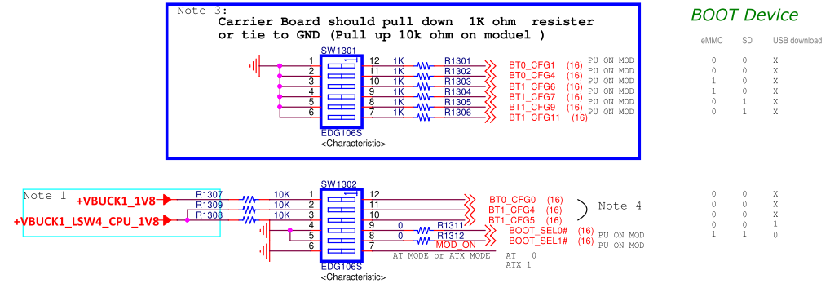

Figure 29 : ROM-ED91 Boot Configuration circuit

BOOT_SEL 0/1
The OSM Hardware Specification defines two low active input contacts BOOT_SEL0# and BOOT_SEL1# which may be used to tell the Module what physical device to do a BCT boot from.
As allowed boot media differ between Module Vendors there is no fixed boot configuration within OSM Specification. However, the Module Vendor must specify the configuration necessary on the Carrier Board.
An example of a boot table delivered by the OSM Module Vendor is shown in Table 33. BOOT_SELx# only has to be pulled down or left floating as there are 10 kΩ on-module pull-ups.
When Boot_SEL 1/0 config to [1,0], the ROM-2620 will boot from boot configuration pins. Please check the Boot configuration section define the BT0_CFGx and BT1_CFGx, and follow the table 33 to set the boot configuration setting.

Table 33 BOOT MODE of the Boot selection pins
Boot _SEL[1:0] |  | BOOT TYPE
Boot _SEL1# | Boot _SEL0# | BOOT TYPE
0 | 0 | Boot from fuse
0 | 1 | Serial Downloader
1 | 0 | Boot for Pins
1 | 1 | NXP Test mode

Table 34 ROM-ED91 boot configure table
 | BOOT_SEL1# | BOOT_SEL0# | BT1_CFG11 | BT1_CFG9 | BT1_CFG7 | BT1_CFG6 | BT0_CFG4 | BT0_CFG1
eMMC | High | Low | Low | Low | High | High | Low | Low
SD | High | Low | High | High | Low | Low | Low | Low

2.16.5 Module Terminations
Table 35 Module Terminations
Signal Name | Series Termination (On Module) | Parallel Termination (On Module) | Note
SYS_RST# |  | 10K pull-up to 1.8V
CARRIER_PWR_EN |  | 10K pull-up to 1.8V  And 2.2uF to GND
BOOT_SEL0# |  | 1K pull-up to 1.8V
BOOT_SEL1# |  | 1K pull-up to 1.8V
SDIO_A_CD# |  | 10K pull-up to 1.8V
SDIO_A_WP |  | 10K pull-up to 1.8V
USB_A_ID |  | 10K pull-up to 1.8V
USB_A_OC# |  | 10K pull-up to 1.8V
USB_B_ID |  | 10K pull-up to 1.8V
USB_B_OC# |  | 10K pull-up to 1.8V
I2C_A_SCL |  | 2.2K pull-up to 1.8V
I2C_A_SDA |  | 2.2K pull-up to 1.8V
I2C_B_SCL |  | 2.2K pull-up to 1.8V
I2C_B_SDA |  | 2.2K pull-up to 1.8V
PWR_BTN# |  | 100K pull-up to 1.8V
I2C_CAM_SDA |  | 2.2K pull-up to 1.8V
I2C_CAM_SCL |  | 2.2K pull-up to 1.8V
Vendor Defined (B22, C16, P16, D6, D7) |  | 10K pull-up to 1.8V | ROM-2620 Module uses these pins be boot configuration, and Carrier Board should use < 1K resistor pull-down. Please check the section: 2.16.4 Boot configuration.
RESERVED(T18) |  |  | ROM-2620 Module uses this pin be boot configuration, and Carrier Board should use < 1K resistor pull-down. Please check the section: 2.16.4 Boot configuration.
RESERVED(Y13) |  | 100K pull-down to GND | ROM-2620 Module uses this pin be boot configuration. If not needed, please do not connect it, the Carrier board should be floating.
RESERVED (T19, Y14) |  | 100K pull-down to GND | ROM-2620 Module uses these pins be boot configuration. If not needed, please do not connect it, the Carrier board should be floating.
JTAG_TDO |  | 10K pull-up to 1.8V

2.16.6 Reserved
The Module RESERVED contacts (up to 55 contacts for Size-L) should normally be left unconnected and may be used in future revisions of the OSM specification.
The ROM-2620 uses the 4 reserved pins T18, T19, Y13, and Y14, which are already defined as boot configuration pins. Please follow the specified table.
Table 36 Rom-2620 RESERVED Interface Pins out
Contact Name | CPU Pin-Out | OSM 1.1V Definition Pin | Description | I/O Level | Note
RESERVED | AB5 | Y13 | BT0_CFG0 | I 1.8V | Unconnected, Floating.
RESERVED | J4 | Y14 | BT1_CFG4 | I 1.8V | Unconnected, Floating.
RESERVED | F1 | T19 | BT1_CFG5 | I 1.8V | Unconnected, Floating.
RESERVED | H1 | T18 | BT1_CFG7 | I 1.8V | Pull up 10K on Module, Carrier Board pull down to GND should less than or equal to 1K.  Please check the section: 2.16.4 Boot configuration

2.16.7 Vendor Defined Contact
Because of SOC and architecture specific reasons there may be the requirement for module specific functions of power-management or interface signals. They may be not covered by known standards.
OSM Hardware Specification fulfills this need by adding up to 19 (for size L) vendor specific contacts.
The ROM-2620 used the 5 Vendor Defined pins that D6, D7, P16, B22, and C16 already defined to boot configuration pins. Please follow the table used.

Table 37 Rom-2620 Vendor Defined Interface Pins out
Contact Name | CPU Pin-Out | OSM 1.1V Definition Pin | Description | I/O Level | Note
Vendor Defined | AD5 | D6 | BT0_CFG1 | I 1.8V | Pull up 10K on Module, Carrier Board pull down to GND should less than or equal to 1K.
Vendor Defined | AD4 | D7 | BT0_CFG4 | I 1.8V | Pull up 10K on Module, Carrier Board pull down to GND should less than or equal to 1K.
Vendor Defined | J5 | P16 | BT1_CFG6 | I 1.8V | Pull up 10K on Module, Carrier Board pull down to GND should less than or equal to 1K.
Vendor Defined | K2 | B22 | BT1_CFG9 | I 1.8V | Pull up 10K on Module, Carrier Board pull down to GND should less than or equal to 1K.
Vendor Defined | K1 | C16 | BT1_CFG11 | I 1.8V | Pull up 10K on Module, Carrier Board pull down to GND should less than or equal to 1K.

2.16.8 Voltage Test Contacts
Up to 8 dedicated contacts (VCC_x_TEST) for voltage test points are specified. These contacts are intended to be used by module vendor for test procedures. Usage and voltages are vendor specific. See module specification if connection of these contacts on own Carrier Board is allowed or must be unconnected.
The ROM-2620 used the 2 pins of VCC_2_TEST and VCC_3_TEST, please check the table as the below.

Table 38 Rom-2620 VCC_x_TEST Interface Pins out
Contact Name | OSM 1.1V Definition Pin | Description | I/O Level | NOTE
VCC_2_TEST | M19 | Module power voltage test point | O 1.8V | From Module "+VBUCK1_LSW1_CPU_1V8" [14]
VCC_3_TEST | Y16 | Module power voltage test point | O 1.8V | From Module "+VBUCK1_1V8" [14]

Note 14 : +VBUCK1_LSW1_CPU_1V8 and +VBUCK1_1V8 PWR rails are come from the MOD that used for Carrier Board Power on sequence logic pull high and the Boot configurations pull high. Not for power supply.

Electrical Characteristics

Absolute Maximum Ratings

Table 39 Absolute Maximum Ratings
OSM module |  | MIN | MAX | UNIT
Power | VCC_IN_5V | 4.75 (5-5%) | 5.25 (5+5%) | V
Power | RTC Battery | 2.4 | 3.3 | V

DC Characteristics

Table 4.2 Maximum Ratings
NXP i.MX 8ULP
Power Plane | Maximum Power Consumption
Symbol |  | OFF
VCC_IN_5V
RTC Battery |  | ~ 6.4uA

3.3 Power Management Signals

Table 40 Power Management Signal Definitions
Contact Name | OSM 1.1V Definition Pin | Description | I/O Level | NOTE
VCC_2_TEST | M19 | Module power voltage test point | O 1.8V | From Module "+VBUCK1_LSW1_CPU_1V8" [15]
VCC_3_TEST | Y16 | Module power voltage test point | O 1.8V | From Module "+VBUCK1_1V8" [15]
VCC_IN_5V | Y8, Y9, Y10, Y11, Y17 | Module power input voltage of 5V | I 5V
GND | D18, E15, E21, F16, F20, J16, J20, L18, M16, M20, P18, R16, R20, V16, V20, Y18, AA14, AA17, AA19, AA22, AB15, AB21,A4, A7, A10, B2, B5, B8, B9, C11, D1, D5, D8, E2,H2, H4, L2, L4, P2, P4, R1, U2, U4, V1, W3, Y2, AA1, AA4, AA7, AA8, AA10, AA11, AB3, AB6, AB9, AC4, AC7, AC10 | Module Signal and power return and GND reference | P

Note 15 : +VBUCK1_LSW1_CPU_1V8, +VBUCK1_1V8, and +VBUCK1_LSW4_CPU_1V8 PWR rails are come from the MOD that used for Carrier Board Power on sequence logic pull high and the Boot configurations pull high. Not for power supply.

Table 41 Power Management Signal Definitions
Contact Name | OSM 1.1V Definition Pin | Description | I/O Level
SYS_RST# | U17 | Reset input from Carrier board. Carrier drives low to force a Module reset, floats the line otherwise. | I 1.8V
CARRIER_PWR_EN | V17 | Carrier board circuits should not be powered up until the module asserts the CARRIER_PWR_EN signal | O 1.8V
VCC_OUT_IO | U18 | Can provide IO voltage level for several interfaces to connect | P 1.8V < 100mA. Only provide voltage to the logic ICs and ICs that need pull-up on the Carrier board when there is no power on the carrier board. Check the section 3.3.1  If not used, please keep floating.
RTC_PWR | W17 | Low current RTC circuit backup power – 3.0V nominal. May be sourced from a Carrier based Lithium cell or Super Cap. | P
FORCE_RECOVERY# | T17 | If low on carrier board module enters recovery mode. | NA, used the BOOT_SEL0# / BOOT_SEL1#.
PWR_BTN# | AA9 | Power-button input from Carrier board. Carrier to float the line in in-active state. Active low, level sensitive. Should be de-bounced on the Module. | I 1.8V

3.3.1 CARRIER_PWR_EN
The CARRIER_PWR_EN signal driven by the module at 1.8 V level. It is a high active output to signal that the Carrier Board power supplies are allowed to be powered up. Normally this signal is integrated within the module's internal power-up sequence and is switched high within the last sequence before reset release.

Note 16 : Implementation of this signal on the Carrier Board is strongly recommended as it prevents cross-supplying through I/O domains that are powered down on the module. Cross-supplying can result in.

The ROM-2620 used the RC circuit on CARRIER_PWR_EN signal, so the ROM-ED91 used the open drain buffer IC to be the signal buffer and used the ROM-2620 module power VCC_OUT_IO(1.8V) be the buffer IC power source when the carrier board was without the power rail ready.
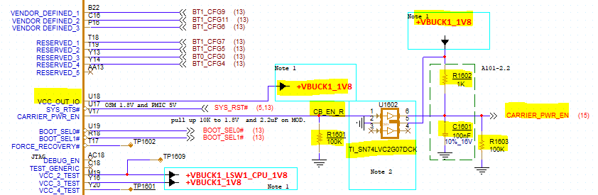
Figure 30 : ROM-ED91 Carrier_PWR_EN circuit

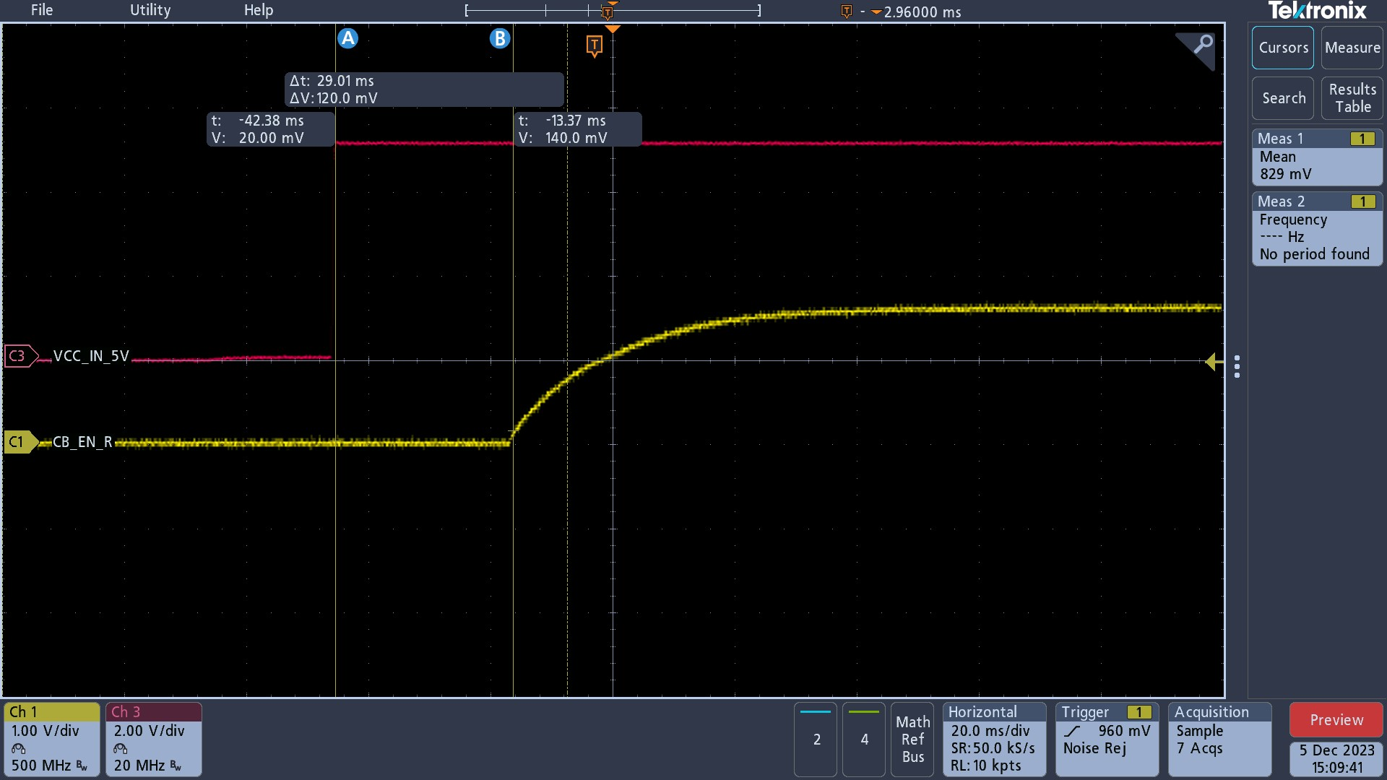
Figure 31 : The ROM-2620 Carrier_PWR_EN RC rise waveform

3.3.2 SYS_RST#
The SYS_RST# signal is driven by the Carrier Board and must only be pulled to the ground or left floating. It has an internal pull up to 1.8 V on-module. This signal may be used to force the Module to stay in reset.
If used, by the Carrier, then an open drain device or switch to GND should be used. A switch example is shown in Figure 28. The signal is ESD protected in this example, as the switch (and the switch interaction with humans) introduces an ESD hazard.
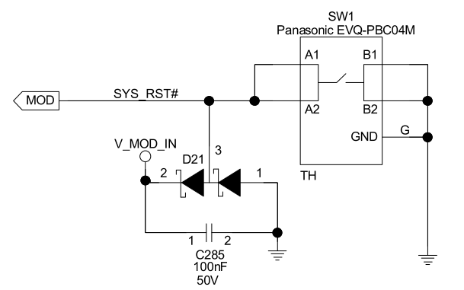
Figure 32 : Reset button Key design

Note 17 : The ROM-2620 design the SYS_RST# be the PMIC reset in, it would cause the system cold reset. The carrier board can’t use this pin be the carrier board power ok signal.

Note 18: Repeatedly use of the SYS_RST# signal while the Module is already performing a reset cycle might lead to unknown behavior of the Module and therefore shall be avoided.

3.3.2 PWR_BTN#
OSM defines a contact to allow the implementation of a Carrier board power button.
If possible, add ESD protection. The ROM-ED91 power button key design is as below, that MOD_ON for first-time power rail on. The ONOFF is sent to the module CPU, after the firs-time power up the CPU will monitor this signal to be on/ off controlled.

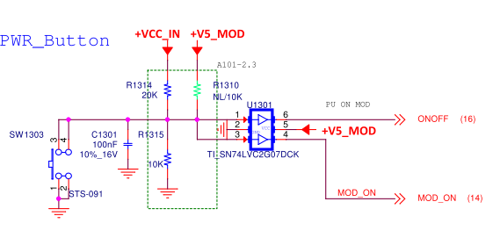
Figure 33 : ROM-ED91 Power button Key circuit

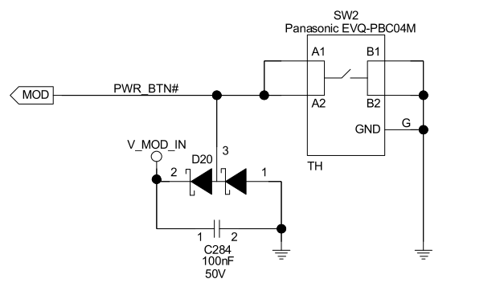

Figure 34 : Power button Key circuit with ESD

3.3.3 Power on sequence

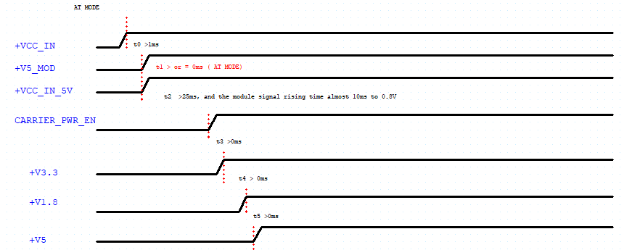
Figure 35 : ROM-ED91 AT Power-On Sequence

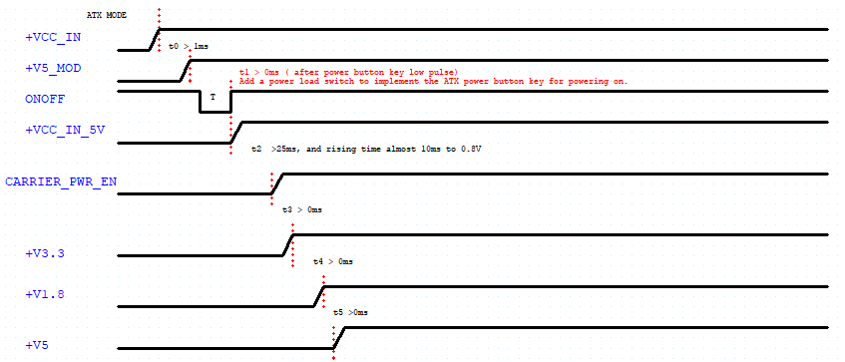
Figure 36 : ROM-ED91 ATX Power-On Sequence (check the 3.3.6 AT and ATX section)

Table 42 Power Management Timings
Sym |  | Description | Min | Max
T | Power Button |  | 0.5s | 4s
t1 | The +V12A is stable to the +V5_MOD |  | 1ms
t2 | Carrier_PWR_EN |  | 25ms | 40ms
t3 | +V3.3 |  |  | 3ms
t4 | +V1.8 |  |  | 4ms
t5 | +V5 |  |  | 4ms

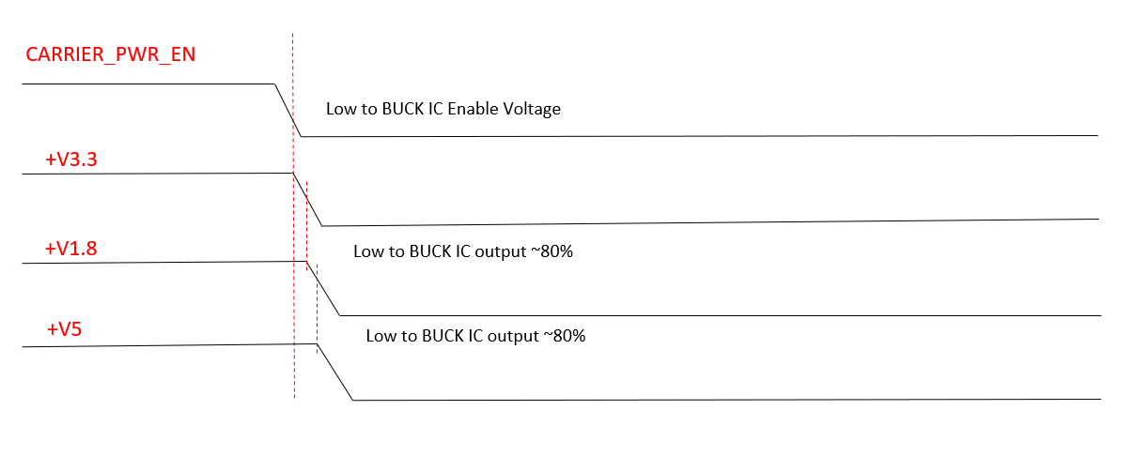

Figure 37 : ROM-ED91 Power-off Sequence (Note 19: Case by designer request)

3.3.4 ROM-2620 Module Input
The primary supply voltage depends on the OSM Module size. A single supply of 5 V is recommended for Size-S, Size-M and Size-L on up to 17 contacts (VCC_IN_5V).
There are currently no limits in the OSM Module Hardware Specification on the Module power supply rise times. In general, it is not wise to expose the Module and Carrier electronics to extremely fast power supply rise times (as may be the case if a low impedance power source such as a battery pack or power brick is “hot-plugged”). Input power supply rise times faster than 50 V/ms to the Module should be avoided.

The OSM Module physical contact consists of a soldered connection able to carry a current of minimum 0.5 A per contact.
Depending on the module size there are different amounts of contacts for the power input VCC_IN_5V thus the limited input power differs for each module size. The following table shows the amount of input power contacts and the allowed maximum input power.

Table 43 Limiting Input Power
Module Size | VCC_IN_5V
Module Size | Contacts | Input Power
Size-0 | 1 | 2.5 W
Size-S | 5 | 12.5 W
Size-M | 9 | 22.5 W
Size-L | 17 | 42.5 W

3.3.5 DC Input and OVP/OCP Protect
The power path for a basic, fixed input voltage arrangement OSM Module and Carrier board system is shown in Figure 38. The figure also shows the ROM-ED91 Carrier Board power supply section's typical system powered by a power source of type 12 V. Designers can choose the power solution that they need.
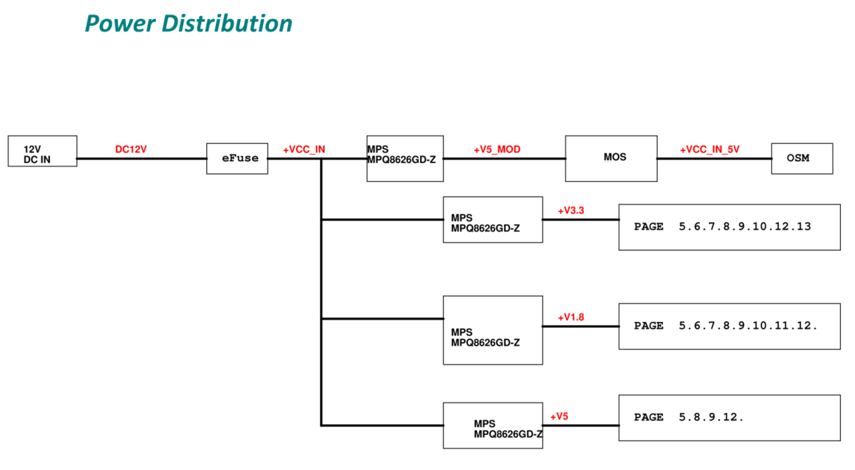
Figure 38 : ROM-ED91 Power Distribution

Over-current Protection
For safety reasons, the main power supply path should be fused. There should be a fuse placed between the system's power supply output and the customized carrier board's power supply input. This fuse may be standard or could also be a poly fuse. Either one is sufficient. The maximum current must be tested and determined by the carrier board designer.

3.3.6 AT and ATX
ATX
The ROM-2620(i.MX8ULP) system automatically powers on during the initial power supply. Subsequently, the system can be controlled for power on/off functionality via the onoff pin(power button key).
Therefore, the designer must add a load switch before VCC_IN_5V to implement ATX power supply control via the power button key.

Based on the ROM-ED91 circuit design, pressing the PWR_BTN# signal pulls it low, which turns on the PMOS. Once the power switch is turned on and delivers +VCC_IN_5V, this voltage latches the power PMOS in the on state. After the initial power-up of the ROM-2620, the CPU takes over control of power management using the ONOFF signal.

AT
When the system support AT, the designer should design the +VCC_IN_5V power rail to the ROM-2620 without using any power switch. Because the i.MX8ULP can automatically power on the system during the initial power-up.

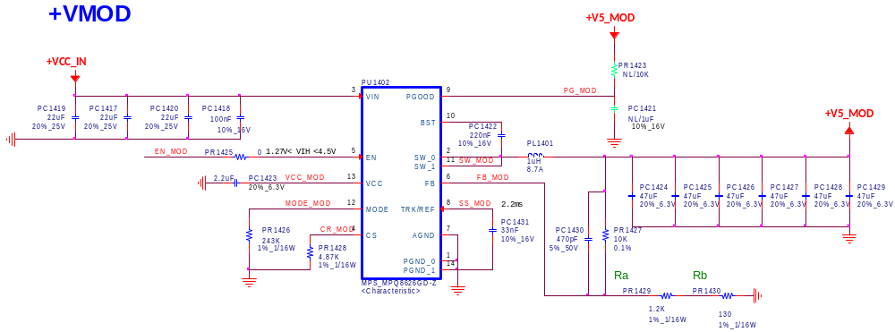

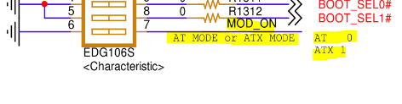
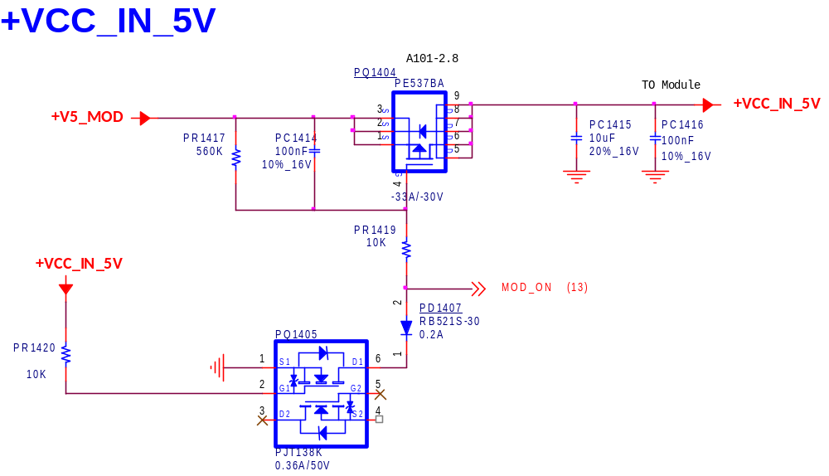
Figure 39 : ROM-ED91 Module Power Circuit

Figure 40 : Module Power for AT and ATX

3.4 FORCE_RECOVERY#
ROM-2620 won’t support this pin, because the system can set the BOOT_SEL1/0 to [0,1] and the system will into USB download mode. Designer can use the USB_A 2.0 client mode into USB download mode by NXP tools.

3.5 RTC Battery
The Real-Time Clock (RTC) is responsible for maintaining the time and date even when the module is not connected to the main power supply. Usually, a +3V lithium battery cell is used to supply the internal RTC of the module. The OSM specification defines an extra power pin 'RTC_PWR', which connects the RTC of the module to the external battery. The specified input voltage range of the battery is defined between +2.4V and +3.3V. The signal 'VCC_RTC' can be found on the module's connector pin W17.

3.5.1 RTC Battery Lifetime
The RTC battery lifetime determines the time interval between system battery replacement cycles. Current leakage from the RTC battery circuitry on the carrier board is a serious issue and must be considered during the system design phase. The current leakage will influence the RTC battery lifetime and must be factored in when a specific life expectancy of the system battery is being defined.
To accurately measure the value of the RTC current it should be measured when the complete system is disconnected from AC power.
The RTC power plane is normally used with the 3V3 Voltage on the module, so it may not be necessary to perform this on the carrier board. Please consult the module vendor's documentation.

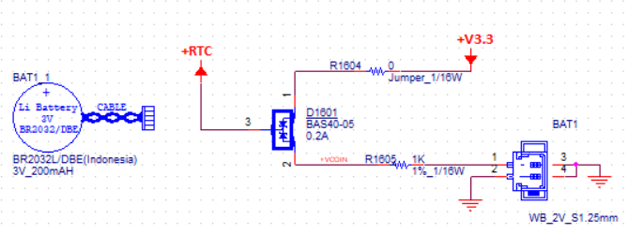

Figure 41 : RTC Circuit.

Mechanism dimension

4.1 Contact Grid
Modules adhering to the Open Standard Module™ Specification shall use the following contact grid and the
regarding designation:
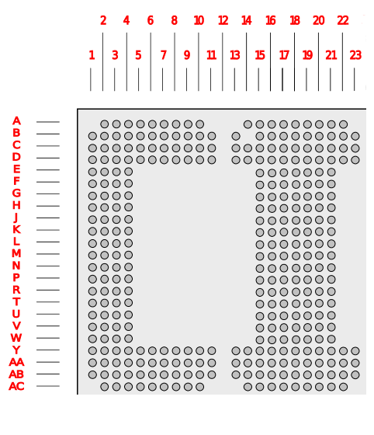

A1

Figure 42 : Contact Grid (view from top, through the module)
A1
A1
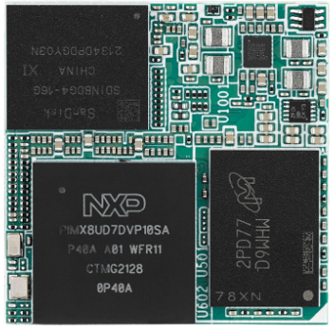
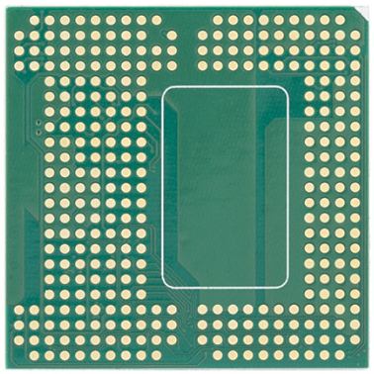

Figure 43 : ROM-2620 View from TOP & ROM-2620 Flip View

4.2 Footprint Grid
The Contact Grid for the Open Standard Module™ Specification is symmetrically and defines the
following dimensions:
▪ Contact Diameter: 0.8 mm
▪ Contact Grid: 1.25 mm
▪ Contact-to-Contact: 0.45 mm
▪ Contact-to-Edge: 0.85 mm

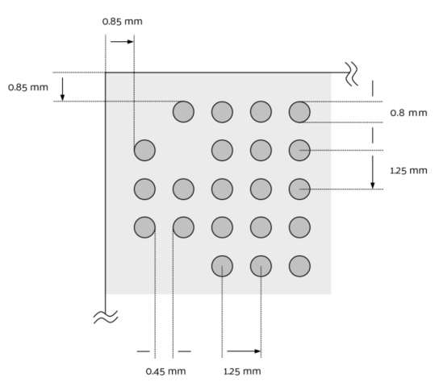

Figure 44 : Footprint Grid Dimensions

4.3 Possible Cut-out and Placement Areas (bottom side)
All modules adhering to the Open Standard Module™ Specification are meant to be soldering modules. Therefore, the definition of placement areas on bottom side of the module is necessary to allow placement of electronic components on the opposite of some main components like CPU, RAM, etc. Predefined placement areas will need to be taken into account for baseboard designs for recesses or cut-out areas. Otherwise, the module PCB itself could be increased with a Spacer PCB layer considering the placement areas on module bottom side.

Optional Placement Area #1: 10.25 mm width x 16.5 mm height
Optional Placement Area #2: 10.25 mm width x 16.5 mm height
Optional Placement Area #3: 31.5 mm width x 7.75 mm height
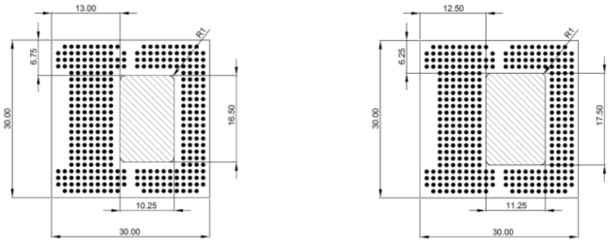

Figure 45: Placement Area (left) and Cut-Out Area (right) - Size S (view from bottom)

4.4 Breakout Area and Tolerances

All modules adhering to the Open Standard Module™ Specification may have predefined panel breakout areas. Within these breakout areas the outline and texture of the module PCB might vary. The definition of breakout areas might facilitate the production of the modules as well as testing equipment and shall reduce potential mechanical intolerances and conflicts on the baseboard. Therefore, the red areas (below) border the maximum tolerances to be considered during production and assembly. The usage of those breakout areas is not a mandatory requirement.

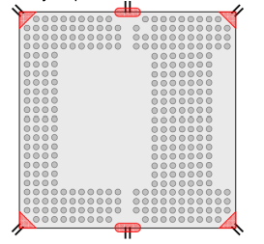

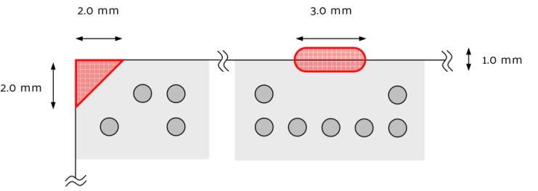

Figure 46 : Breakout Areas (view from top, through the module)

4.5 Outline Dimensions
The Open Standard Module™ is made up of four different sizes that build upon each other. The board outline tolerance should be within ±0.1mm.

Size-S – “Small”: 30 mm x 30 mm

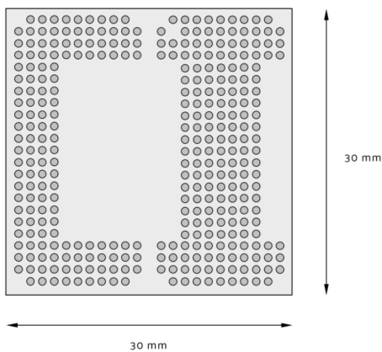

Figure 47 : Size-S Dimension and Footprint (view from top, through the module)

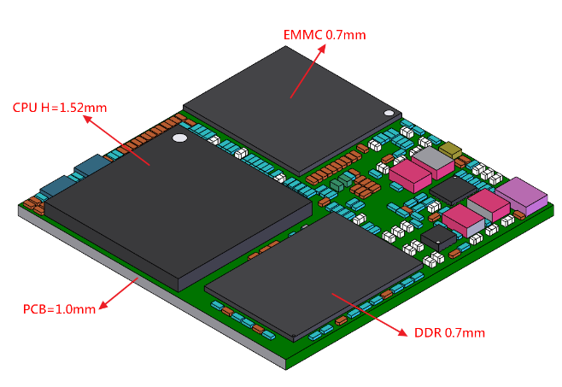

Figure 48 : Module Height

